- Given the dependency diagram shown in Figure 1, answer Questions b & c:

FIGURE 1 The Dependency Diagram

- Create a database whose tables are at least in 2NF, showing the dependency diagrams for each table.

- Create a database whose tables are at least in 3NF, showing the dependency diagrams for each table.

2-
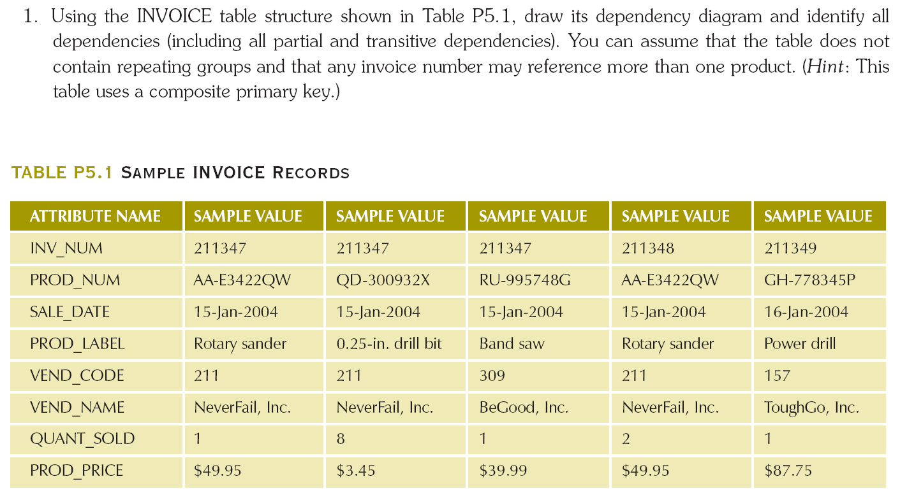

3-
Using the initial dependency diagram drawn in Problem 2, remove all partial dependencies, draw the new
dependency diagrams, and identify the normal forms for each table structure you created.

4-
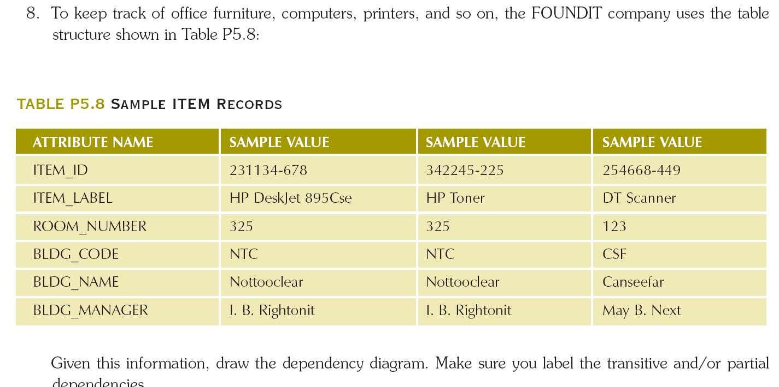

5- Starting with the dependency diagram drawn for Problem 4, create a set of dependency diagrams that meet 3NF requirements. Rename attributes to meet the naming conventions, and create new entities and attributes as necessary.

6- Using the results of Problem 5, draw the Crow’s Foot ERD.

