1. The graph of a tangent function is given. Select the equation for the following graph:
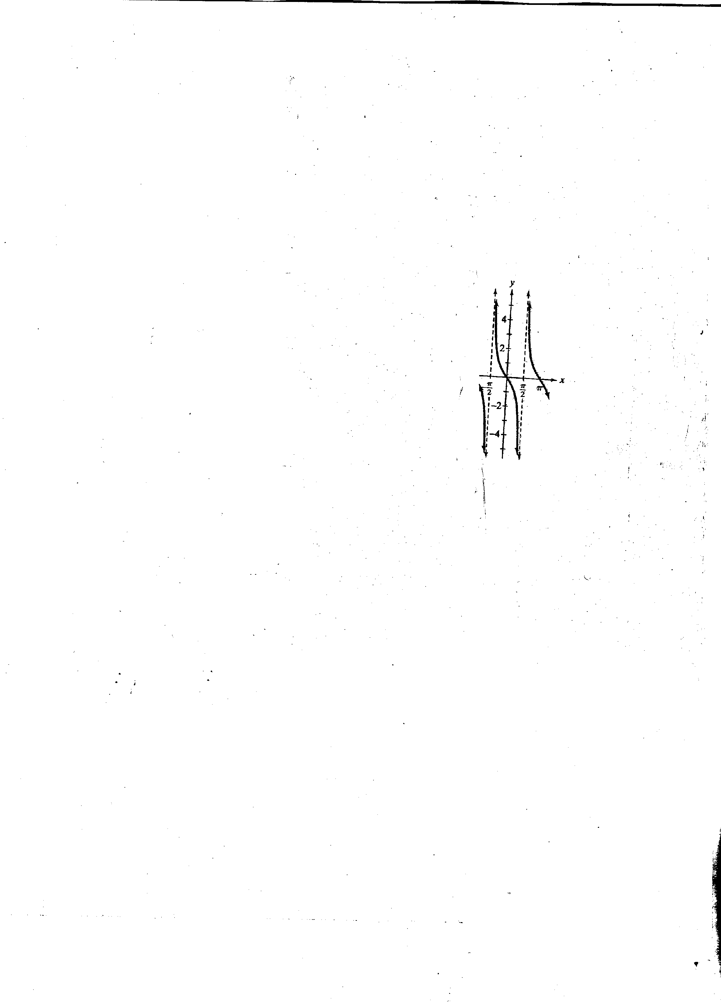
y = tan, y = tan( x +π ), y = tan x, y = tan

2. Graph two periods of the given tangent function.
y = 2 tan 2x

3. Graph two periods of the given cosecant or secant function.
y = 3 sec x

4. The angle of elevation from the top of a house to a jet flying 2 miles above the house is x radians. If d represents the horizontal distance, in miles, of the jet from the house, express d in terms of a trigonometric function of x. Then graph the function for 0 < x < π.

Determine the period of:
5. y = tan x6. y = tan bx
7. y = csc x
8. y = sec x
9. y = tan
10. y = tan 2x

Determine the range of:
11. y = tan x
12. y = tan 2x

Determine the value of y for:
13. y = csc

14. Determine the value of y for the following equation:
y = sec

15. If cos x = 1, what is the value of sec x?

16. If sin x = 1, what is the value of csc x?
17. Solve the equation, cot x = 0, for the given interval of x:
0

18. Solve the equation, cos x = 1 for the given interval of x:
0 ≤ x ≤ 2 π

19. Solve the equation, tan x = 1, for the given interval of x:

20. What is the value of x for which sec x = 1 for the following interval:

21. Determine the value of y for: y = csc

