1. Describe two patterns that you have observed in Pascal’s Triangle.
Mark: 2
2. Which row of Pascal’s Triangle has terms that add up to 64?
Mark: 1
3. Consider the five-square by five-square gameboard given.
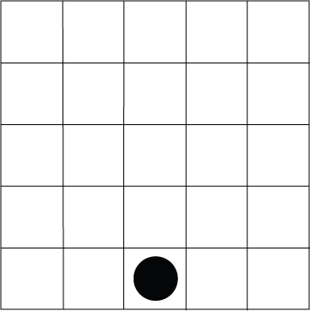
A checker is positioned in the middle of the bottom row. The checker is allowed to move one square at a time, diagonally left or right, to the row above. How many different paths will lead to each position in the top row?
Mark: 3
4. If the numerical coefficients are disregarded, the following terms appear in the expansion of (x + y)11
State the value of k in each case:
a) x2 yk
b) xk y11
Mark: 4
5. In the arrangement of the letters given, starting from the top, one proceeds to the row below by moving diagonally to the immediate right or left. How many different paths will spell each of the following words.
a) BINOMIAL
B
I I
N N N
O O O O
M M M
I I
A
L L
b) THEOREM
T
H H
E E E
O O O O
R R R
E E E E
M M M M M
Mark: 4
6. In the expansion of (x² – x)⁸ find the coefficient of x⁸.
Mark: 2
7. Find the first three terms in the expansion of :
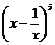
Mark: 2
8. In the expansion of 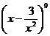 find the following:
a) the term containing x6
b) the constant term
Mark: 2

