EXAMPLE: THE PRODUCT-MIX MODEL

MBI Corporation makes special-purpose computers. A decision must be made: How many computers should be produced next month at the Boston plant? Two types of computers are considered: the CC-7, which requires 300 days of labor and $10,000 in materials, and the CC-8, which requires 500 days of labor and $15,000 in materials. The profit contribution of each CC-7 is $8,000, whereas that of each CC-8 is $12,000. The plant has a capacity of 200,000 working days per month, and the material budget is $8 million per month. Marketing requires that at least 100 units of the CC-7 and at least 200 units of the CC-8 be produced each month. The problem is to maximize the company’s profits by determining how many units of the CC-7 and how many units of the CC-8 should be produced each month. Note that the data in the problem statement could possibly take months to determine in a real-world environment, and that while gathering the data, the decision maker would no doubt uncover facts about how he or she would structure the model to be solved.

MODELING

A standard mathematical modeling technique called linear programming (LP) is applicable. It has three components:

Decision variables
X₁ = units of CC-7 to be produced;
X₂ = units of CC-8 to be produced

Result variable
Total profit = Z. The objective is to maximize total profit: Z = 8,000X₁ + 12,000X₂

Uncontrollable variables (constraints):
Labor constraint: 300X₁ + 500X₂ ≤ 200,000 (in days)
Budget constraint: 10,000X₁ + 15,000X₂ ≤ 8,000,000 (in dollars)
Marketing requirement for CC-7: X₁ ≥ 100 (in units)
Marketing requirement for CC-8: X₂ ≥ 200 (in units)

The model also has a fourth, hidden component. Every linear programming model has some internal intermediate variables that are not explicitly stated. The labor and budget constraints may each have some “slack” in them when the left-hand side is strictly less than the right-hand side. These slacks are represented internally by slack variables that indicate excess resources available. The marketing requirement constraints may each have some “surplus” in them when the left-hand side is strictly greater than the right-hand side. These surpluses are represented internally by surplus variables indicating that there is some room to adjust the right-hand sides of these constraints.

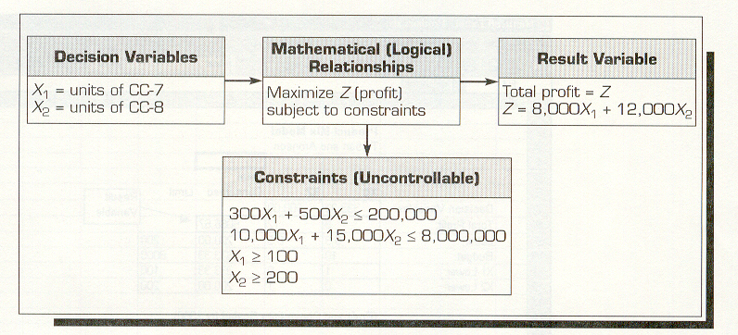

These slack and surplus variables are intermediate. They can be of great value to the decision maker because linear programming solution methods use them in establishing sensitivity parameters for economic what-if analyses.

The product-mix model has an infinite number of possible solutions. Assuming that a production plan is not restricted to whole numbers – a reasonable assumption in a monthly production plan – we want a solution that maximizes total profit – an optimal solution.

Fortunately, Excel comes with the add-in Solver that can readily obtain an optimal (best) solution to this problem. We enter these data directly into an Excel spreadsheet, activate Solver, and identify the goal (set Target Cell equal to Max), decision variables (By Changing Cells), and constraints (Total Consumed elements must be less than or equal to Limit for the first two rows and must be greater than or equal to Limit for the third and fourth rows). Also, in Options, activate the boxes Assume Linear Model and Assume Non-negative and then solve the problem. Solve, then select all three reports – Answer, Sensitivity, and Limits – to obtain an optimal solution of X₁ = 333.33, X₂ = 200, Profit = $5,066,667. Solver produces three useful reports about the solution.

The most common optimization models are:

- Assignment (best matching of objects)
- Dynamic programming
- Goal programming
- Investment (maximizing rate of return)
- Linear and integer programming
- Network models for planning and scheduling
- Nonlinear programming
- Replacement (capital budgeting)
- Simple inventory models
- Transportation (minimize cost of shipments)


