  - A majority verdict of 10-2 or better may be permitted in a jury trial. Assuming each
juror has probability 0.9 of reaching a Guilty verdict, and decides independently,
what is the probability the jury decides to convict?

Partial solution:
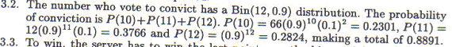

  - For both the Gamma and Beta distribution, find the value of x that maximises the
density function. When is there just one local maximum?
Partial solution:
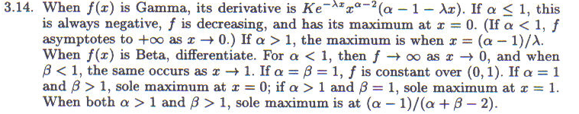

  - The Logarithmic distribution has been used in ecology to model how often any particular species appears in a habitat. Its pgf is of the form cln(1 – qz), where c is a constant and 0 < q < 1. Find c in terms of the parameter q, and write down the expression fo pk, the chance a species is located k times.
Partial solution:

3.12 Eleven horses enter a race. Mr C takes exactly 60 second to complete the course. Each of the other ten horses, independently, takes more than 60 seconds with probability p, or less than 60 seconds with probability 1 – p. Give a model for Mr C’s position in the race. Find the chances that he wins, and he is placed
(i.e. in the first three).
Find the value of p that makes all eleven horses equally likely to win. For this
value of p, find the chance Mr C is placed. Is it a surprise that your last answer is
not 3/11?
Partial solution:


