1. Given the diagram below, find P ∩ Q. Write in correct set notation.
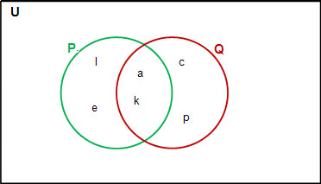

2. Write down all possible subsets of set P using correct set notation.
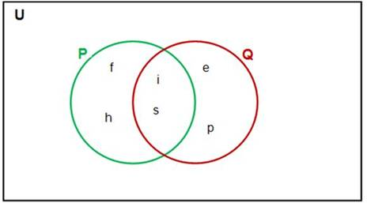

3. The cardinal number of the set {triangle, rectangle, square, trapezoid, octagon, rhombus, circle, ellipse, pentagon} is _________.

4. Given the following sets, select the statement below that is true.
A = {r, i, s, k, e, d}, B = {r, i, s, e}, C = {s, i, r}
B ⊂ A and B ⊂ C
A ⊂ C and C ⊂ B
B ⊆ A and C ⊂ A
C ⊆ A and B ⊆ C
A ⊆ B and C ⊆ B

5. Without writing them all out, what is the number of subsets of set A = {king, queen, knight, prince, princess, duke}?

6. Given the following set, select the statement below that is true.
V = {a, e, i, o, u}
i ∉ V
v ∈ V
5 ∈ V
V Ø
Ø V
7. Given these sets:
A = {1, 2, 3, 4}
B = {3, 4, 5, 6, 7}
C = {3, 5, 7, 9}
List the elements of this set
B(A∩C)
Show your work, step by step.

8. The National Association for Women in Science asked recent high school grads if they had taken certain science classes. Of those surveyed, 28 said they had taken physics, 47 said they had taken chemistry and 13 said they had taken both. Twelve said they had taken neither. How many recent high school grads were surveyed?

9. The President’s Council on Fitness asked adults who exercise if they walk, run or stretch. Here is the Venn diagram of the results. Of those adults surveyed, how many ran but did not stretch?
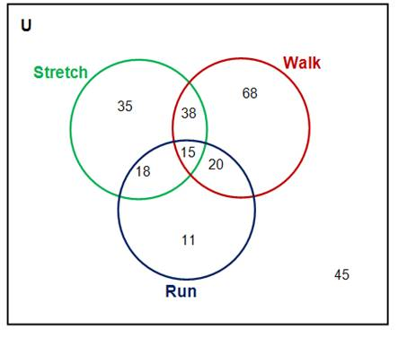

10. A charity asked people attending a fundraiser cookout if they ate the salad, casserole or dessert. Here is the Venn diagram of the results. Of those surveyed, how many people ate dessert and casserole?
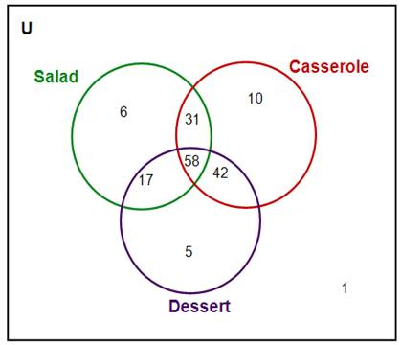

11. The Wildlife Federation surveyed 170 San Diego residents. The results are as follows:
26 had a membership to the Birch Aquarium
44 had a membership to the San Diego Zoo
17 had both
Construct a Venn diagram and answer the following questions:
i. How many had only a zoo membership?
ii. How many had only an aquarium membership?
iii. How many belonged to either one or the other or both?
iv. How many belonged to neither?

