Can you show work on the last set of problems I attempted to do the first two problems however, I don’t know if that is right.
Thanks

2. Assume the standard normal distribution. Fill in the blanks
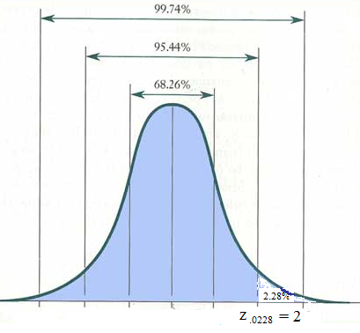 | (a) P( z < 2.00 ) = .9773  (b) P( z < -1.24 ) = .1075  (c) P( z > ) = .0793  (d) P( z > ) = .9929  (e) z.₀₂ =  (f) z.₇₅ =  (g) z.₉₀ =  (h) z.₃₅ =

