E 12-1, E 12-4, E 12-6, P 12-9, P 12-12, P 12-14
E 12-1
The Befort Company filed for a patent on a new type of machine. The application costs totaled $12,000. R&D costs incurred to create the machine were $75,000. In the year in which the company filed for and received the patent, it spent $20,000 in the successful defense of a patent infringement suit.
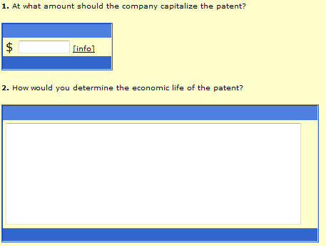
E 12-4
- Kling Company was organized in late 2007 and began operations on January 2, 2008. Prior to the start of operations, it uncured the following costs:
Costs of hiring new employees $3,000
Attorney’s fees in connection with the organization of the company 12,000
Improvements to leased offices prior to occupancy (10-year lease) 6,000
Costs of pre-opening advertising 5,000
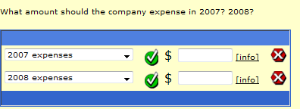
E 12-6
In 2007, Lalli Corporation incurred R&D costs as follows:
Materials and equipment $100,000
Personnel 100,000
Indirect costs 50,000
$250,000
These costs relate to a product that will be marked in 2008. The company estimates that these costs will be recouped by December 31, 2011.
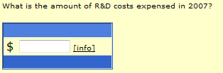
P 12-9
The controller of the Halpern Company prepared the following income statement and balance sheet at the end of the first year of the company’s existence.
Income Statement
Sales Revenue $40,000
Cost of sales (20,000)
Operating expenses (8,000)
Net income 12,000

Balance Sheet
Cash $33,000 Accounts payable $5,000
Inventory 24,000 Notes payable 40,000
R&D costs 30,000 Common stock 50,000
Property, plant, and equip 20,000 Retained earnings 12,000
$107,000 $107,000
Investigation shows that R&D costs include, among others, half the years operating costs because “the company is not yet operating at capacity.” In addition R&D costs include $5,000 of materials that were wasted during early production because “our employees made some unnecessary mistakes.”
Required:
- Prepare the financial statements according to GAAP.
- Compute the company’s return on assets under both the original and revised financial statements.
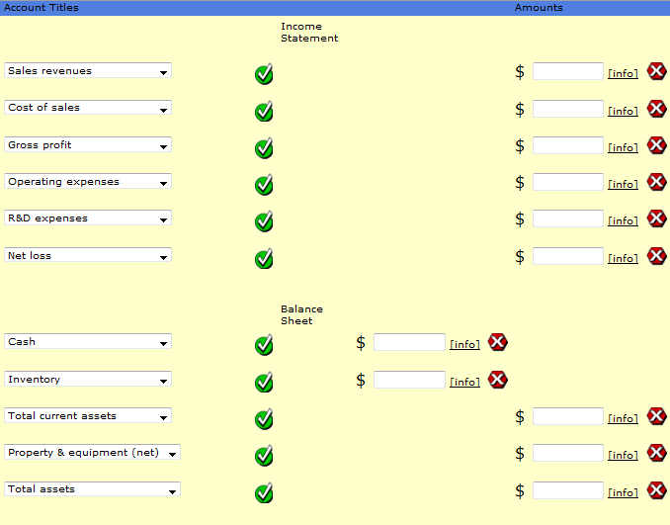
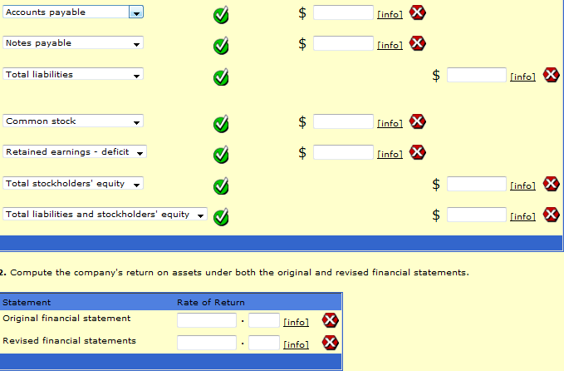
P 12-12
The Hamilton Company balance sheet on January 1, 2007 was as follows:
Cash $30,000 Current liabilities $20,000
Accounts receivable 80,000 Bonds payable 120,000
Marketable securities 40,000 Pension liability 50,000
Inventory 100,000 Common stock 200,000
Property, plant, equip 200,000 Retained earnings 60,000
$450,000 $450,000

The Korbel Company is considering purchasing the Hamiltion Company (a privately held company) and discovers the following about the Hamiltion Company:
- No allowance for uncollectables has been established. A $10,000 allowance is considered appropriate.
- Marketable securities are valued at cost. The current market value is $60,000.
- The LIFO inventory method is used. The FIFO inventory of $140,000 would be used if the company is acquired.
- Land, included in property, plant, and equipment, which is recorded at its cost of $50,000, is worth $120,000. The remaining property, plant, and equipment is worth 10% more than its depreciated cost.
- The company has an unrecorded trademark that is worth $70,000.
- The company’s bonds are currently trading for $130,000 and the common stock for $300,000.
- The pension liability is understated by $40,000.
Required:
- Compute the value of the implied goodwill if the Korbel Company agrees to pay $500,000 cash for the Hamilton Company.
- Prepare the journal entry to record the acquisition on the books of the Korbel Company, assuming the Hamilton Company is liquidated.
- If the Korbel Company agrees to pay only $400,000 cash, how much is the implied goodwill?
- If the Korbel Company pays only $400,000 cash, prepare the journal entry to record the acquisition on its books assuming the Hamilton Company is liquidated.
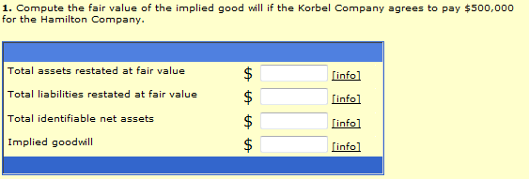
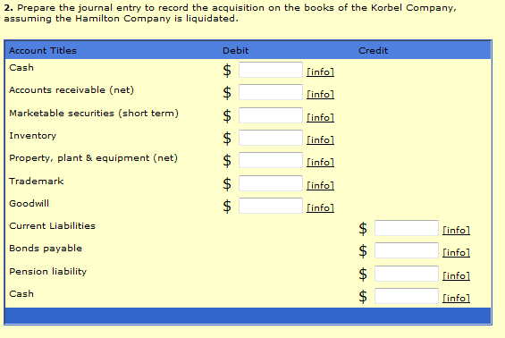
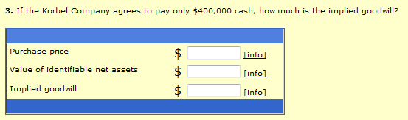
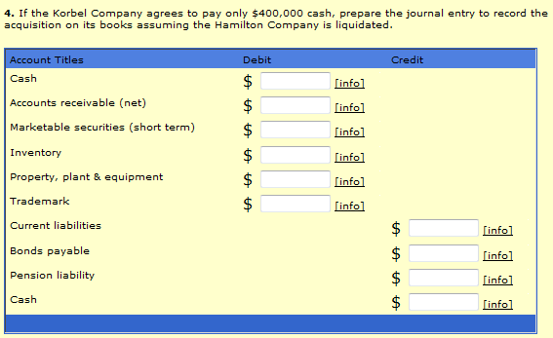

P 12-14
The Barb Company has provided information on intangible assets as follows:
- A patent was purchased from the Lou Company for $1,500,000 on January 1, 2006. Barb estimated the remaining useful life of the patent to be 10 years. The patent was carried in Lou’s accounting records at a net book value of $1,250,000 when Lou sold it to Barb.
- During 2007, a franchise was purchased from the Rink Company for $500,000. In addition, 5% of revenue from the franchise must be paid to Rink. Revenue from the franchise for 2007 was $2,000,000. Barb estimates the useful life of the franchise to be 10 years and takes a full year’s amortization in the year of purchase.
- Barb incurred R&D costs in 2007 as follows:
Materials and equip $120,000
Personnel 140,000
Indirect costs 60,000
$320,000
Barb estimates that these costs will e recouped by Dec 31, 2008.
- On January 1, 2007 Barb, based on new events that have occurred in the field, estimates that the remaining life of the patent purchased on January 1, 2006 is only five years from January 1, 2007.
Required:
- Prepare a schedule showing the intangibles section of Barbs balance sheet at Dec 31, 2007. Show supporting computations in good form.
- Prepare a schedule showing the income statement effect for the year ended Dec 31, 2007 as a result of the previously mentioned facts. Show supporting computations in good form.
