1-
Suppose that you are a manufacturer of product ABC, which is composed of parts A, B, and C. Each time a new product is created, it must be added to the product inventory, using the PROD_QOH in a table named PRODUCT. And each time the product ABC is created, the parts inventory, using PART_QOH in a table named PART, must be reduced by one each of parts A, B, and C. The sample database contents are shown in Table P1

Table P1 The Database for Problem 1
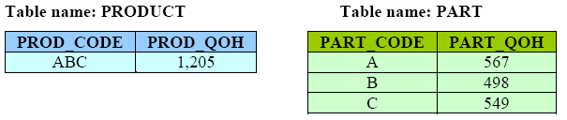
Given this information, answer questions a-e.

a. How many database requests can you identify for an inventory update for both PRODUCT and PART?

b. Using SQL, write each database request you have identified in Step a.

c. Write the complete transaction(s).

d. Write the transaction log, using Table 10.1 as your template.

e. Using the transaction log you created in Step d, trace its use in database recovery.

2-
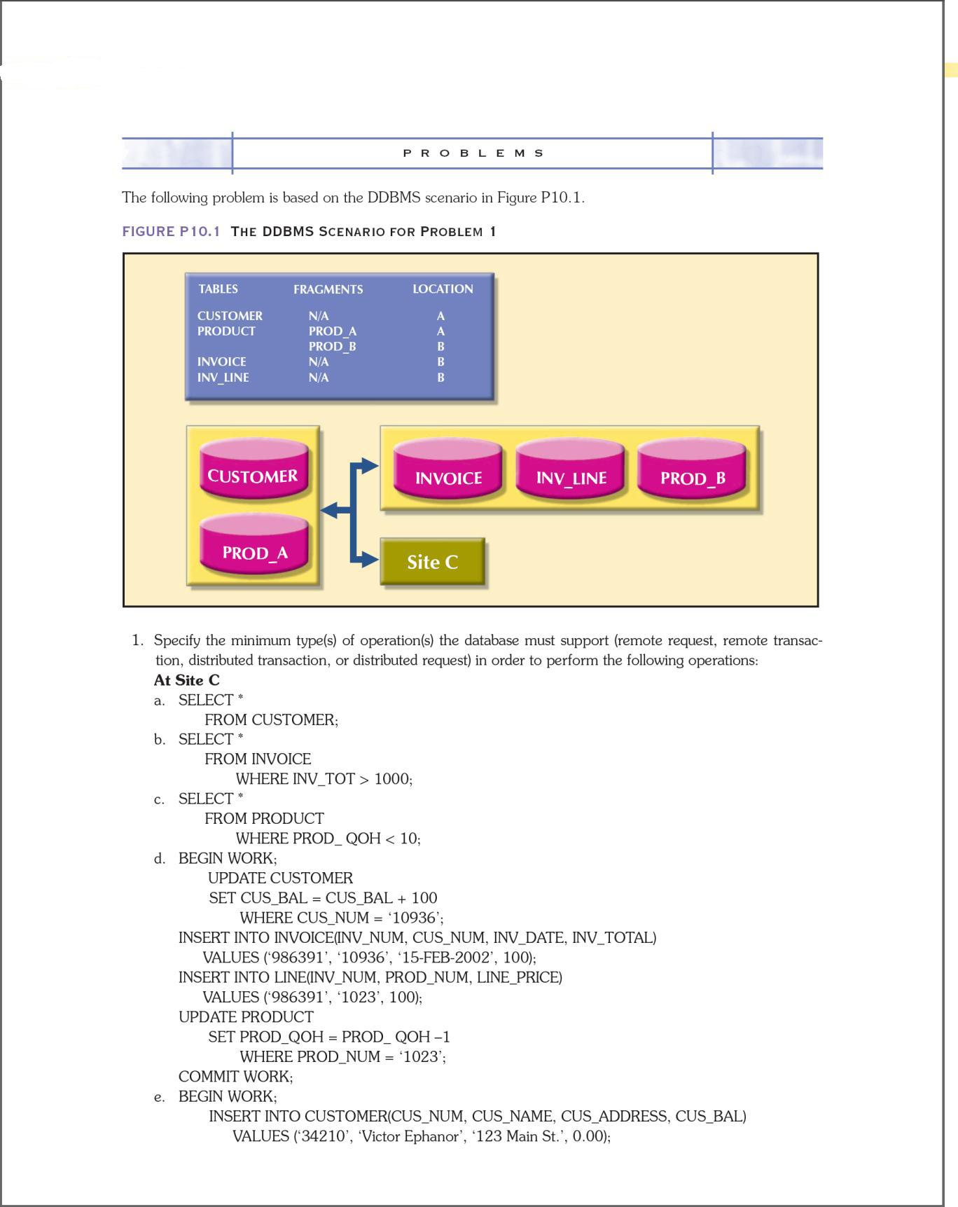
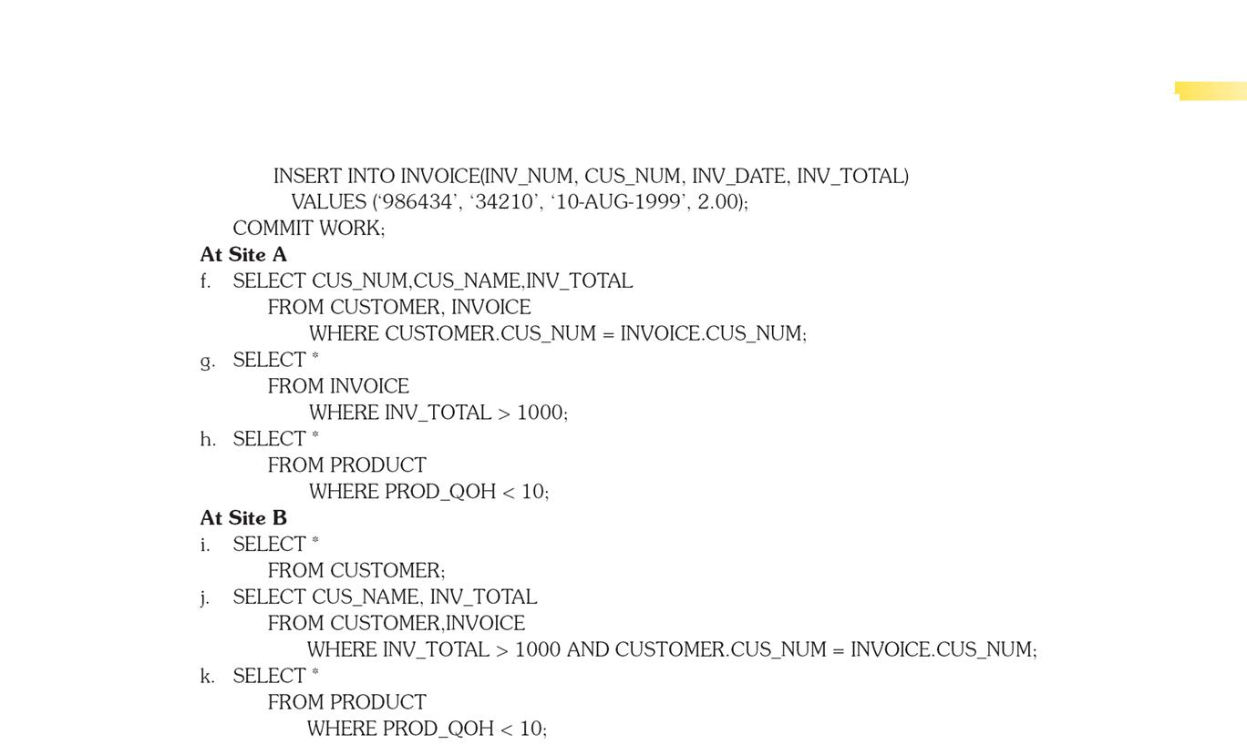

3- What are the different types of query optimization algorithms?

4- Describe three data fragmentation strategies. Give some examples of each.

5- What is data replication, and what are the three replication strategies?

