A4
Consolidated Statement of Income
PepsiCo, Inc. and Subsidiaries
Fiscal years ended December 31, 2005, December 25, 2004 December 27, 2003
(in millions except per share amounts) 2005 2004 2003
Net Revenue...................................................................................... $32,562 $29,261 $26,971
Cost of sales...........................................................................................14,176 12,674 11,691
Selling, general and administrative expenses ........................................12,314 11,031 10,148
Amortization of intangible assets.............................................................150 147 145
Restructuring and impairment charges.................................................... 150 147
Merger-related costs............................................................................................................... 59
Operating Profit......................................................................................5,922 5,259 4,781
Bottling equity income............................................................................. 557 380 323
Interest expense..................................................................................... (256) (167) (163)
Interest income......................................................................................... 159 74 51
Income from Continuing Operations before Income Taxes ................6,382 5,546 4,992
Provision for Income Taxes................................................................... 2,304 1,372 1,424
Income from Continuing Operations.......................................................4,078 4,174 3,568
Tax Benefit from Discontinued Operations ....................................................................38
Net Income ............................................................................................. $ 4,078 $ 4,212 $ 3,568
Net Income per Common Share — Basic
Continuing operations ..............................................................................$2.43 $2.45 $2.07
Discontinued operations.................................................................................................... 0.02
Total ...........................................................................................................$2.43 $2.47 $2.07
Net Income per Common Share — Diluted
Continuing operations ...............................................................................$2.39 $2.41 $2.05
Discontinued operations.................................................................................................... 0.02
Total ........................................................................................................$2.39 $2.44* $2.05
* Based on unrounded amounts.

Net Revenue Operating Profit
Income from Continuing Operations Net Income per Common Share — Continuing Operations

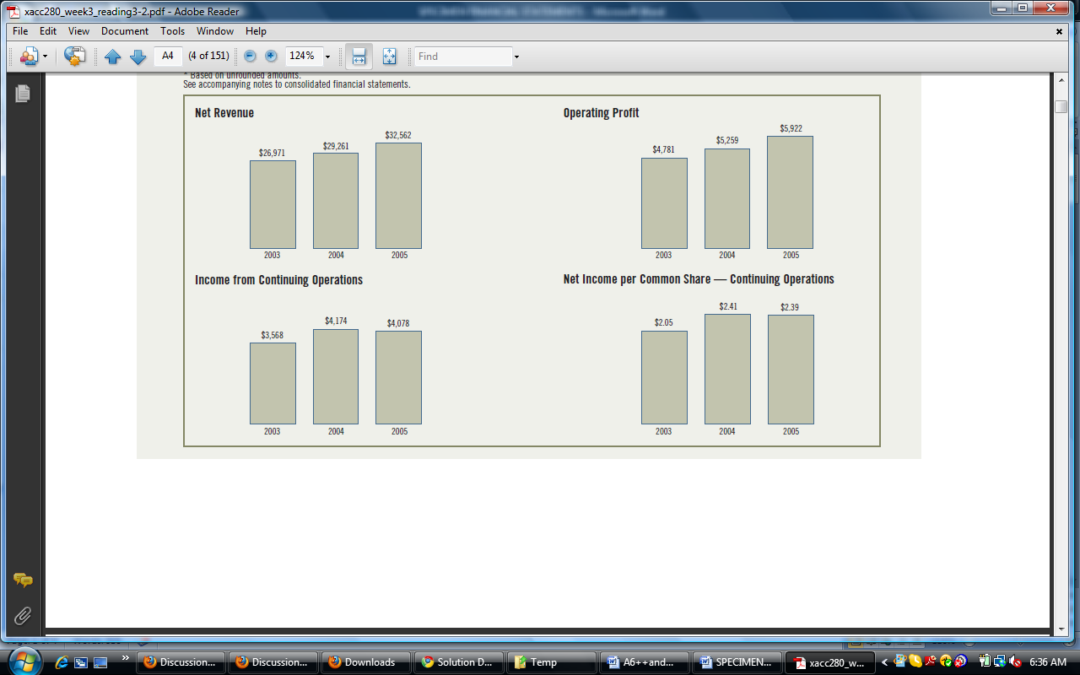

A6 Appendix A Specimen Financial Statements: PepsiCo, Inc.
Consolidated Balance Sheet
PepsiCo, Inc. and Subsidiaries
December 31, 2005 and December 25,2004
(in millions except per share amounts) 2005 2004
ASSETS 2005 2004
Current Assets
Cash and cash equivalents.................................................................................................................................. $ 1,716 $ 1,280
Short-term investments ....................................................................................................................................... 3,166 2,165
4,882 3,445
Accounts and notes receivable, net....................................................................................................................... 3,261 2,999
Inventories............................................................................................................................................................ 1,693 1,541
Prepaid expenses and other current assets........................................................................................................... 618 654
Total Current Assets ...................................................................................................................................... 10,454 8,639
Property, Plant and Equipment, net .................................................................................................................... 8,681 8,149
Amortizable Intangible Assets, net...................................................................................................................... 530 598
Goodwill................................................................................................................................................................ 4,088 3,909
Other nonamortizable intangible assets................................................................................................................ 1,086 933
Nonamortizable Intangible Assets.................................................................................................................. 5,174 4,842
Investments in Noncontrolled Affiliates .............................................................................................................. 3,485 3,284
Other Assets ........................................................................................................................................................ 3,403 2,475
Total Assets............................................................................................................................................... $31,727 $27,987
LIABILITIES AND SHAREHOLDERS’ EQUITY
Current Liabilities
Short-term obligations ......................................................................................................................................... $ 2,889 $ 1,054
Accounts payable and other current liabilities...................................................................................................... 5,971 5,599
Income taxes payable........................................................................................................................................... 546 99
Total Current Liabilities ................................................................................................................................. 9,406 6,752
Long-Term Debt Obligations................................................................................................................................ 2,313 2,397
Other Liabilities ................................................................................................................................................... 4,323 4,099
Deferred Income Taxes....................................................................................................................................... 1,434 1,216
Total Liabilities............................................................................................................................................... 17,476 14,464
Commitments and Contingencies
Preferred Stock, no par value ............................................................................................................................. 41 41
Repurchased Preferred Stock............................................................................................................................ (110) (90)
Common Shareholders’ Equity
Common stock, par value 1 2/3¢ per share (issued 1,782 shares)....................................................................... 30 30
Capital in excess of par value.............................................................................................................................. 614 618
Retained earnings ................................................................................................................................................ 21,116 18,730
Accumulated other comprehensive loss ................................................................................................................ (1,053) (886)
20,707 18,492
Less: repurchased common stock, at cost (126 and 103 shares, respectively) ................................................... (6,387) (4,920)
Total Common Shareholders’ Equity .............................................................................................................. 14,320 13,572
Total Liabilities and Shareholders’ Equity ................................................................................................ $31,727 $27,987

SPECIMEN FINANCIAL STATEMENTS:
The Coca-Cola Company
AppendixB
B1
THE COCA-COLA COMPANY AND SUBSIDIARIES
CONSOLIDATED STATEMENTS OF INCOME
Year Ended December 31, 2005 2004 2003
(In millions except per share data)
NET OPERATING REVENUES $ 23,104 $ 21,742 $ 20,857
Cost of goods sold 8,195 7,674 7,776
GROSS PROFIT 14,909 14,068 13,081
Selling, general and administrative expenses 8,739 7,890 7,287
Other operating charges 85 480 573
OPERATING INCOME 6,085 5,698 5,221
Interest income 235 157 176
Interest expense 240 196 178
Equity income — net 680 621 406
Other loss — net (93) (82) (138)
Gains on issuances of stock by equity investees 23 24 8
INCOME BEFORE INCOME TAXES 6,690 6,222 5,495
Income taxes 1,818 1,375 1,148
NET INCOME $ 4,872 $ 4,847 $4,347
BASIC NET INCOME PER SHARE $ 2.04 $ 2.00 $ 1.77
DILUTED NET INCOME PER SHARE $ 2.04 $ 2.00 $1.77
AVERAGE SHARES OUTSTANDING 2,392 2,426 2,459
Effect of dilutive securities 1 3 3
AVERAGE SHARES OUTSTANDING ASSUMING DILUTION 2,393 2,429 2,462
Refer to Notes to Consolidated Financial Statements.
The financial information herein is reprinted with permission from The Coca-Cola Company 2005
Annual Report. The accompanying Notes are an integral part of the consolidated financial statements.
The complete financial statements are available through a link at the book’s companion
website.

B2 Appendix B Specimen Financial Statements: The Coca-Cola Company
THE COCA-COLA COMPANY AND SUBSIDIARIES
CONSOLIDATED BALANCE SHEETS
December 31, 2005 2004
(In millions except par value)
ASSETS
CURRENT ASSETS
Cash and cash equivalents $ 4,701 $ 6,707
Marketable securities 66 61
Trade accounts receivable, less allowances of $72 and $69, respectively 2,281 2,244
Inventories 1,424 1,420
Prepaid expenses and other assets 1,778 1,849
TOTAL CURRENT ASSETS 10,250 12,281
INVESTMENTS
Equity method investments:
Coca-Cola Enterprises Inc. 1,731 1,569
Coca-Cola Hellenic Bottling Company S.A. 1,039 1,067
Coca-Cola FEMSA, S.A. de C.V. 982 792
Coca-Cola Amatil Limited 748 736
Other, principally bottling companies 2,062 1,733
Cost method investments, principally bottling companies 360 355
TOTAL INVESTMENTS 6,922 6,252
OTHER ASSETS 2,648 2,981
PROPERTY, PLANT AND EQUIPMENT — net 5,786 6,091
TRADEMARKS WITH INDEFINITE LIVES 1,946 2,037
GOODWILL 1,047 1,097
OTHER INTANGIBLE ASSETS 828 702
TOTAL ASSETS $ 29,427 $ 31,441
LIABILITIES AND SHAREOWNERS’ EQUITY
CURRENT LIABILITIES
Accounts payable and accrued expenses $ 4,493 $ 4,403
Loans and notes payable 4,518 4,531
Current maturities of long-term debt 28 1,490
Accrued income taxes 797 709
TOTAL CURRENT LIABILITIES 9,836 11,133
LONG-TERM DEBT 1,154 1,157
OTHER LIABILITIES 1,730 2,814
DEFERRED INCOME TAXES 352 402
SHAREOWNERS’ EQUITY
Common stock, $0.25 par value; Authorized — 5,600 shares;
Issued — 3,507 and 3,500 shares, respectively 877 875
Capital surplus 5,492 4,928
Reinvested earnings 31,299 29,105
Accumulated other comprehensive income (loss) (1,669) (1,348)
Treasury stock, at cost — 1,138 and 1,091 shares, respectively (19,644) (17,625)
TOTAL SHAREOWNERS’ EQUITY 16,355 15,935
TOTAL LIABILITIES AND SHAREOWNERS’ EQUITY $ 29,427 $ 31,441

