1. Lines l and m are parallel and are cut by the transversal shown. Determine the measures of angles 1 through 7. Include correct units with each part of your solution.
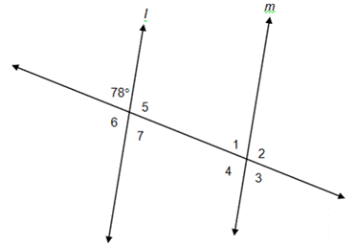
2. Find the volume of the pyramid with a rectangular base shown below.
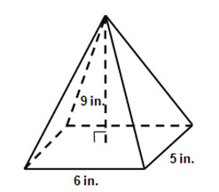
210 cubic inches
84 cubic inches
30 cubic inches
70 cubic inches
58 1/3 cubic inches

3. Use the figure below to find the following
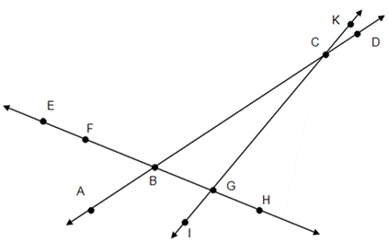
i. < ICA$∩ \overset{⃡}{FG}$
ii. < ABH $∩ <EBD$
iii. < CBG $∩ <$KCA

