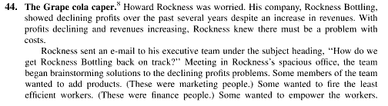
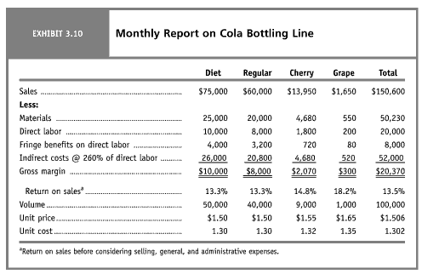
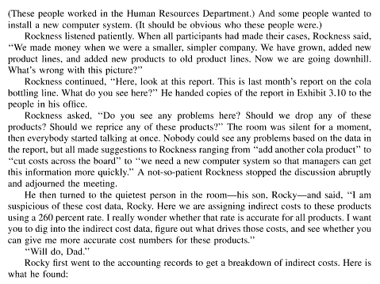
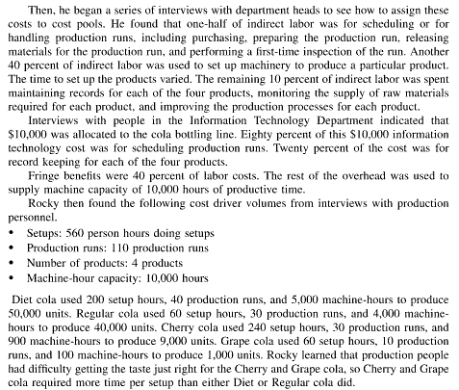

I have already complete the first par t of this question as follows:
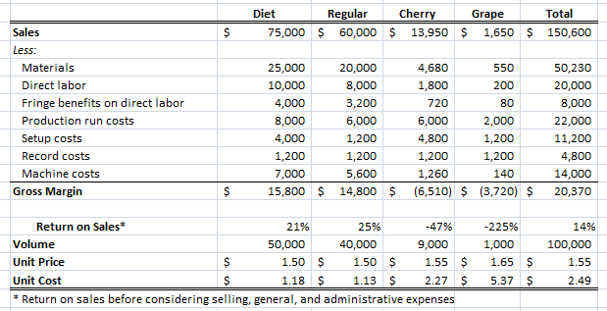

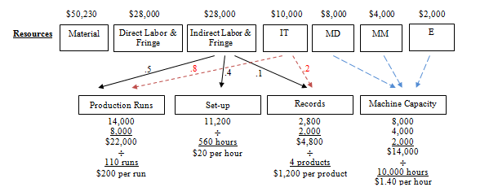
The question I am having a problem with is:
Question: Consider this situation independently. Suppose that Howard Rockness (the Dad) simply decided to eliminate the Cherry and Grape lines. In the template below, provide Rockness a monthly income statement assuming sales volumes of Diet and Regular remain unchanged, (Note: Be sure you justify your assumptions regarding the behavior of each of the costs that would be incurred if Rockness did this). Reference supporting calculations.

