Answer the following questions based on the attached graphs, and associate each scenario with a real-world commodity and a suitable market.

a) Would you describe the following graph as a decrease in demand or a decrease in quantity demanded? What factors might cause this change?

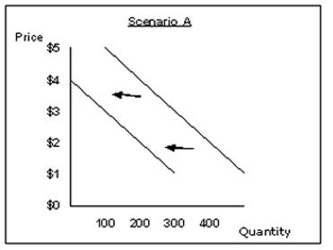

b) Does the following graph show a decrease in demand or a decrease in quantity demanded?

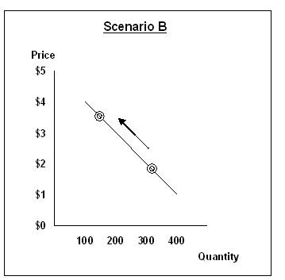

c) Does the following graph as an increase in supply or an increase in quantity supplied? What factors might cause this change?
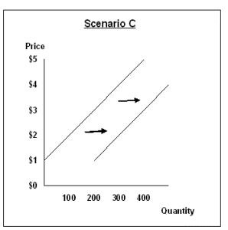
d) Does the following graph as an increase in supply or an increase in quantity supplied?

