Classify nitrogen atoms as Primary, Secondary, or Quaternary Compounds
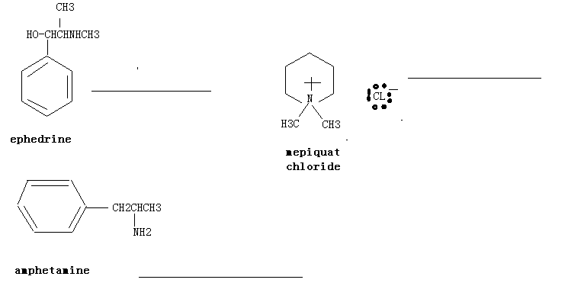
IUPAC Naming
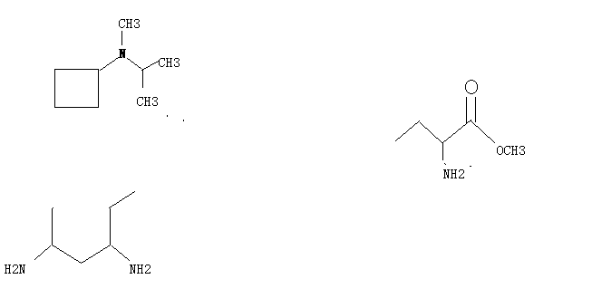

Covert the Following Fischer projections into tetrahedral representations and assign R or S stereochemistry to each.
