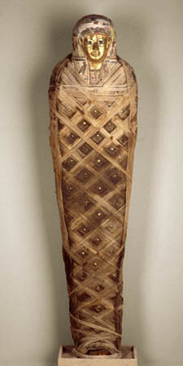
FIRST FUNERAL ITEM
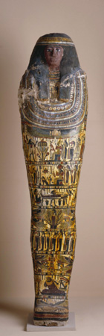
The mummy case image OR mummy cartoonage 1
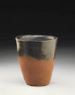
The black-toped pot 1

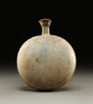New Year's Gift Bottle 1

