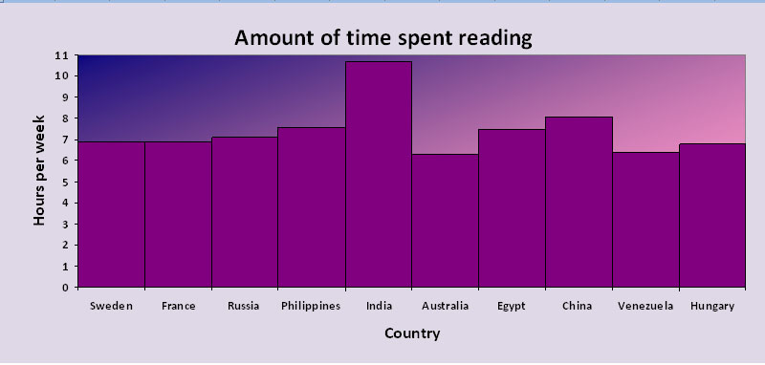
Given the histogram, create a grouped frequency distribution

Below are the blood types of 16 blood donors.

O- A+ O- O+ AB- A-
A+ B+ O+ A+ B- O+
A- O+ B- B+

- Make a frequency table using these 7 blood types: O+, O-, A+, A-, B+, B-, AB-

Using your frequency table draw a pie chart to display the distribution of blood types by filling in the following table:

Using your frequency table draw a pie chart to display the distribution of blood types by filling in the following table:

