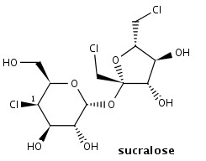
1.) Map each carbon atom of the 6-membered ring in sucralose according to this assignment: 1= axial substituent; 2 = equatorial substituent. The carbon with a chlorine has been done for you and is assigned to the axial position.
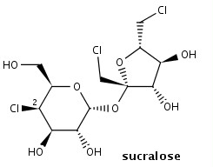
2.) Map each carbon atom of the 6-membered ring in sucralose according to this assignment: 1= axial substituent; 2 = equatorial substituent. The carbon with a chlorine has been done for you and is assigned to the equatorial position.

