- 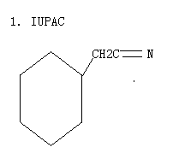

- Even through the para position is one carbon father from the coarboxyl group than the meta position, p-cyanobenzoic acid is more acidic than m-cyanobenzoic acid. Explain the differences in acidity between p-cyanobenzoic acid and m-cyanobenzoic acid.

- Explain the differences in acidity between p-methoxybenzoic and m-methoxybenzoic acid.

- Write the complete stepwise mechanism for the basic hydrolysis of acetamide, shown below. Show all electron flow with arrows and draw all intermediate structures.

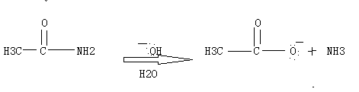

- Consider structures answer questions. Indicate acidic hydrogen molecules. Rank molecules order increasing acidity (least acidic).
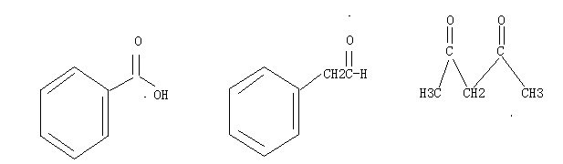

- What order decreasing reactivity nucleophilic acyl substitutions carboxylic acid derivatives? (most relative first)
- 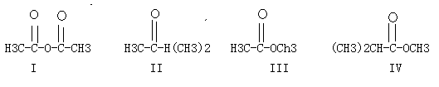

B.