Java programmers can use class hierarchies for the purposes of inheritance. For example, given a Tree class, we could define Conifer and Deciduous sub classes that inherit from the parent Tree class as you can see here:
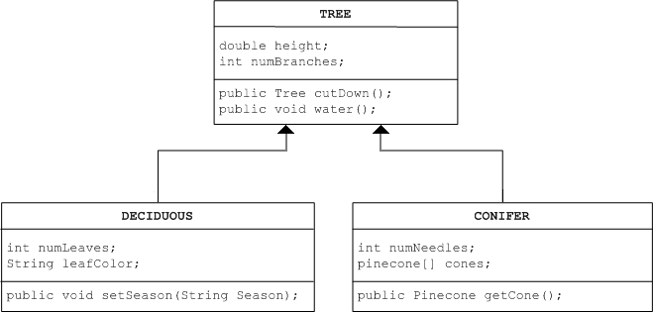
For this learning event, you should develop a similar class hierarchy for Plants. You can have whatever subclasses you think would be useful, but your hierarchy should have at least three levels (the top class, Plants, counts as the first level). Include variables and methods (at least one of each) for each class you design, as in the above example.

