Structure Drawing
- Draw: trans-3-isopropylcyclohexanecarbaldehyde

- IUPAC
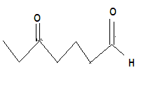

- The exact position of the equilibrium between ketones/aldehydes and their hydrates depends on the structure of the carbonyl compound. Although the equilibrium favors the carbonyl compound in most cases, cyclopranone forms a stable hydrate. Explain this based on the structures of cyclopropanone and its hydrate.

