- Multiply (2-5x⁷)² =_____
- The base of a triangle is 4 cm greater than the height. The area is 30 cm². Find the height and length of the base.
Height is ________cm
Base is _________cm
- (y²-7) (6y²-3y+5) =_______
- Find the greatest common factor (GCF) of 12x and 14x³ The GCF is_____________
- Solve w² = 25
- The solution is_______
- There is no solution.
- The number N, in millions, of hearing impaired people of age x can be approximated by
N = -0.00006x³ + 0.006x² -0.1x + 1.5. Approximate to the nearest million the number of hearing impaired people of age 25 and 35.
N = ________million people of age 25 (round to the nearest million as needed)
N =_________million people of age 35 (round to the nearest million as needed)

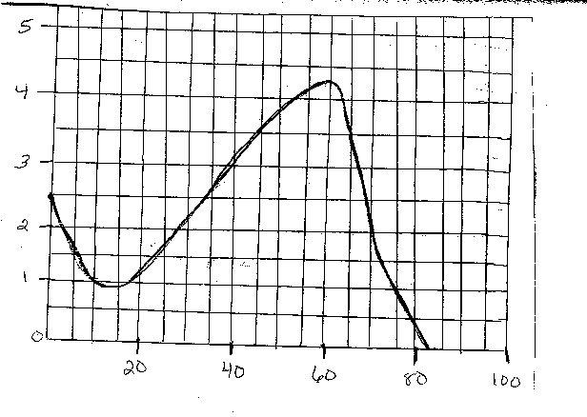
- Simplify (7⁸) -⁵ =_____
- Divide (16x³ -34x² -71 x -21) (8x + 3)=________
- Factor the trinomial r² + 9r +20 =______
- Subtract (xy – ab -8) –(xy – 8ab -1) =_________

- 14x⁸ -42x⁷ + 35x³ _____________ = _______
-7x³
12. Suppose it takes 3 days for a space vehicle to travel from earth to the moon. About how long would it take the same vehicle traveling at the same speed to reach Venus? Closest distance from earth to : moon: 240,000 mi Venus: 26,000,000 mi
The space vehicle would take about _________days to reach venus. (round to the nearest whole number. Use scientific notation.)
13 Simplify (4m⁴)³ =_______
14 For the polynomial, -3x⁴ +7x³ -4x² +5x -1, complete the table
Term coefficient degree of the term degree of the polynomial
____ ______ ________
7x³ 7 ________
____ ______ 2
5x ______ 1
-1 ______ _______

15 Solve c² -14c +45 =0
- The solution is_____
- There is no solution
16 Simplify
- 3² =____
- 3-² =______
- ( 1/3)² =______
- (1/3)-²=_____
- -3²=______
- (-3)²=______
17 Convert to decimal notation. 10-⁴=______
18 factor completely v² +36 -12v =_____
19 evaluate n² -8 when n=-11. n² -8=_____
20 collect like terms. 7x -9x =_____ -
21 factor. 4x² +32x
22 divide and check answer
30x⁴ y² ________
6x ^6 y²

23 multiply and simplify ( 3h )^6 x (3h)³ =______
24 factor 3s⁵-192s² =_____
25 add (8x² -7x +25) + (7x² + 9x -48) =______
27 multiply (x = 3) (x – 3)=_______
28 divide and simply 3^19/3^5 =______
31 multiply (9x² +4) (9x² -4) =_______
32 subtract (1/10x³ -1/4x -1/9) –(-1/10x³ +1/4x -1/9) =________
33 Add (r -3s +1)+(4r + 2s) + (s +1)=________
34 multiply (-1/6x⁵) (-1/5x)=_______
36 express using a positive exponent 1/z^-3=_____
37 Factor by grouping 6x^3 -6x^2 – x + 1=________

