Assignment 3

1. Some games of strategy are cooperative. One example is deciding which side of the road to drive on. It doesn’t matter which side it is as long as everyone chooses the same side. Otherwise, everyone may get hurt.

Driver 2
Left Right
Driver 1 Left 0,0 -1000 -1000
Right -1000, -1000 0,0
a. Does either player have a dominant strategy? Explain.
b. Is there Nash equilibrium in this game? Explain
c. Why this game is called a cooperative game?
2. 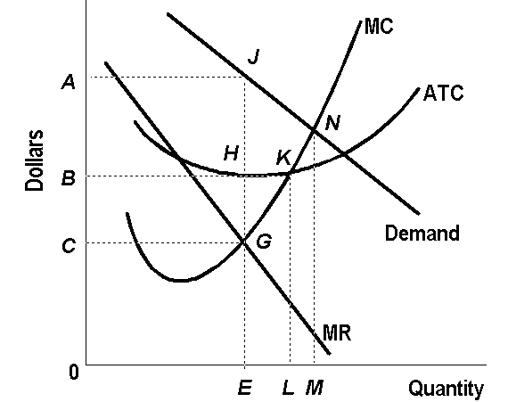
a. What is the firm’s Total Revenue?
b. What is the Total Cost?
c. What is the firm’s Total Profits?
d. If the above monopolist were to behave like a perfectly competitive firm (operating in the long run), determine its output.

Assignment #3

