**Week 4 Individual Assignments**

38. What is the relationship between the amount spent per week on food and the size of the family? Do larger families spend more on food? A sample of 10 families in the Chicago area revealed the following figures for family size and the amount spent on food per week.



a. Compute the coefficient of correlation.

b. Determine the coefficient of determination.

c. Can we conclude that there is a positive association between the amount spent on food and

the family size? Use the .05 significance level.

40. The manufacturer of Cardio Glide exercise equipment wants to study the relationship between the number of months since the glide was purchased and the length of time the equipment was used last week.

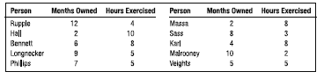

a. Plot the information on a scatter diagram. Let hours of exercise be the dependent variable.

Comment on the graph.

b. Determine the coefficient of correlation. Interpret.

c. At the .01 significance level, can we conclude that there is a negative association between the

variables?

45. Mr. William Profit is studying companies going public for the first time. He is particularly interested in the relationship between the size of the offering and the price per share. A sample of 15 companies that recently went public revealed the following information.

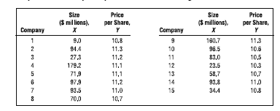

a. Determine the regression equation.

b. Determine the coefficient of determination. Do you think Mr. Profit should be satisfied with

using the size of the offering as the independent variable?