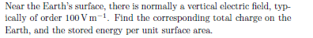

Answer: 4.5 X 10^5 C ; 0.28 J /m^2

