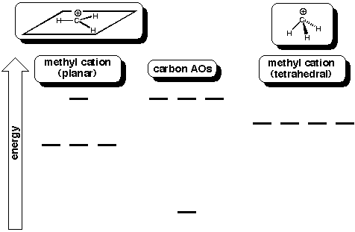
Construct a molecular orbital diagram for each geometry
Which of the following are true:
1. The positively charged carbon atom contributes four valence electrons to the molecular orbitals of the methyl cation.
2. The lowest unoccupied orbital for the planar methyl cation is an sp2 hybrid orbital.
3. The LUMO in the tetrahedral methyl cation is an sp3 hybrid orbital.
4. The LUMO in the tetrahedral methyl cation is lower in energy than the LUMO in the planar methyl cation.
5. The tetrahedral methyl cation is a stronger electrophile than the planar methyl cation.
6. The planar methyl carbon is more reactive than the tetrahedral methyl cation.

