I need help with the following problems. If possible, the program needs to work without any added input.

A ball is dropped with a velocity v0 at an angle a with the vertical onto the top step of a flight of stairs consisting of 8 steps. The ball rebounds and bounces down the steps as shown. Each time the ball bounces, at points A, B, C, . . . , the horizontal component of its velocity remains constant and the magnitude of the vertical component of its velocity is reduced by k percent. Use computational software to determine ( a) if the ball bounces down the steps without skipping any step, ( b) if the ball bounces down the steps without bouncing twice on the same step, ( c) the first step on which the ball bounces twice. Use values of v0 from 1.8 m/ s to 3.0 m/ s in 0.6- m/ s increments, values of a from 18° to 26° in 4° increments, and values of k equal to 40 and 50.

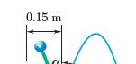

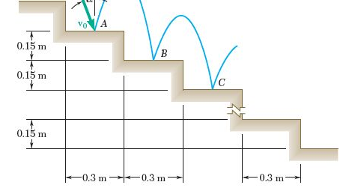

2. Block B of mass 10 kg is initially at rest as shown on the upper surface of a 20- kg wedge A which is supported by a horizontal surface. A 2- kg block C is connected to block B by a cord which passes over a pulley of negligible mass. Using computational software and denoting by U the coefficient of friction at all surfaces, use this program to determine the accelerations for values of U > 0. Use 0.01 increments for U until the wedge does not move and then use 0.1 increments until no motion occurs.
