There is debate within the production planning management team as to which forecasting technique to use. The team members want to test to see which method would be more accurate. They have assigned the new planning director to assess which of the following forecasting techniques would have been more accurate to predict sales in the future.
Using the following sales data for the last 10 quarters, perform a linear regression, and 5-month moving average forecasting techniques to see which is most accurate for the new product if the actual sales for Quarter 11 are 164.
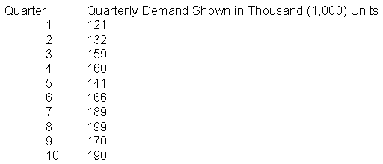
Make sure to include the equation for the line in the linear regression calculation.

