- The Figure below shows the first ionization of a sequence of eight atoms from the
Periodic Table, but not necessarily from the same row. The other given is that N, O and
F occur within the run. Identify all elements involved. Explain your reasoning, and
explain why the ionization energies of atoms X, Y and Z all appear as local minima in the
overall sawtooth pattern.
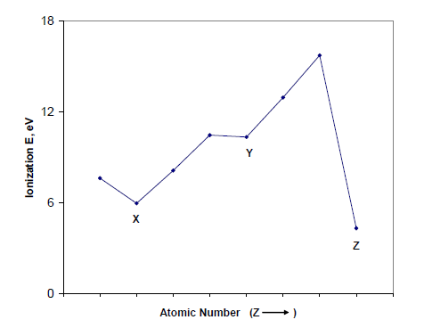

- Why does the first ionization energy increase in the following order?
Al< Ga < B

- The entropy of hydration becomes more negative from Na+ to Mg2+ to Al3+ though the
coordination number is probably 6 in each case. Account for the trend in disorder.
S◦ 298 (J mol-1 K-1) : Na+(aq), 60.3; Mg2+(aq), -138; Al3+(aq), -322.

