1. The figure below shows the forces acting on a tibia when a person stands on the ball of one foot in equilibrium. As shown, the force of the tibia on the ankle joint for a person (of weight 750 N) standing this way is 2800 N. The tibia has a length of 0.4 m, an average inner diameter of 1.3 cm, and an average outer diameter of 2.5 cm. (The central core of the bone contains marrow that has negligible compressive strength. Take the Young's modulus of bone to be 17.0 x 10⁹ Pa.)
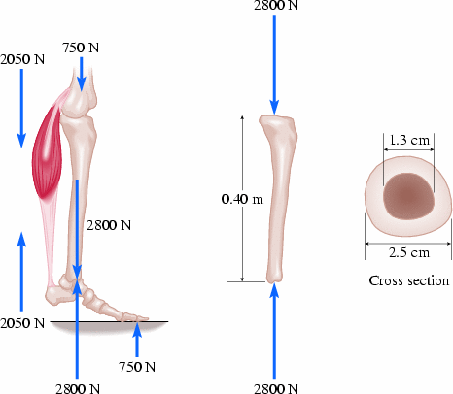

(a) Explain why the force on the tibia isn’t equal to 750 N.

- What is the average cross-sectional area of the tibia (you can assume it’s a circle)?

(c) What is the compressive stress in the tibia?

(d) What is the change in length for the tibia due to the compressive forces?

