Questions to post: Microeconomics, Colander 7th Edition
1. Compute the approximate elasticity of demand from the following data:
Initial Situation: Price: $23 Quantity: 11.5
New Situation: Price: $20 Quantity: 13.5

a. .87
b. 1.15
c. 1.5
d. 5.0

2. Refer to the graph. If market price increases from $5 per unit to $6 per unit, a profit maximizing perfectly competitive firm will:
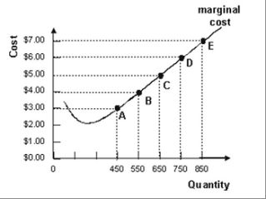
a. increase output from 650 to 750
b. decrease output from 750 to 650
c. continue to produce 650 units
d. produce 850 units of output

3. Refer to the table. Between $1.60 and $1.80, demand is:
a. elastic
b. unit elastic
c. inelastic
d. perfectly elastic
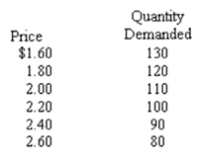
4. Which of the following statements is true about a downward-sloping demand curve that is a straight line?
a. the slope and the elasticity are the same at all points
b. the slope remains the same, but elasticity rises as you move down the demand curve
c. the slope remains the same, but elasticity falls as you move down the demand curve
d. the slope and the elasticity fall as you move down the demand curve

5. A market has the following characteristics: There is strategic decision making, output is somewhat restricted, there are few firms and some long run economic profits are possible. This market is:

a. a monopoly
b. an oligopoly
c. monopolistically competitive
d. perfectly competitive

