40. | The graph below depicts two different types of costs. Questions related to the graph should be answered in the spaces provided.  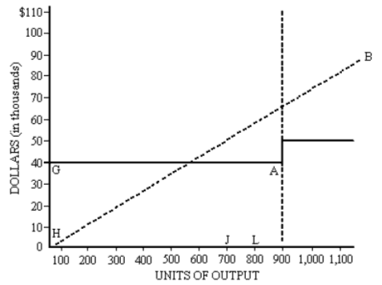  a. The line H-B represents what type of cost? ______________________  b. Production at point J versus point L would __________ total variable costs.  c. Production at point J versus point L would __________ per unit fixed costs.  d. What is a possible reason that line G-A increases at point A to a new horizontal line?  e. What kind of cost is depicted by the line from point G to point A?

