Economics Review Questions
Colander, 7th Edition

1. in the late 1990's mad cow disease caused people to buy less beef. It also caused the eu to ban imported bristish beef and the bristish government to ban the sale of older cattle. What is the effect of the following on price and quanity of British beef sold worldwide?
a. Price of british beef falls and quantity sold also falls
b. Price of bristish beef rises and quantity sold falls
c. Price of bristish beef falls initially, but regains some of its losses. Quantity sold initially rise, then falls
d. Price of british beef falls initially, but regains some of its losses. Quantity sold falls

2. A quantity restriction of QR will:
a. reduce quantity supplied to Q2
b. reduce quantity supplied to QR
c. have no effect on quantity supplied
d. create excess demand represented by Q2 – QR

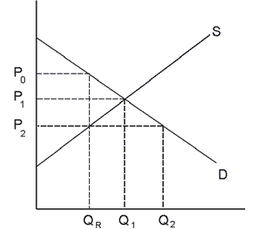

3. Refer to graphs. The consequences of improved technology combined with an increased in the
number of consumers

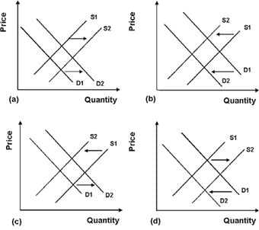

a. graph A
b. graph B
c. graph C
d. graph D

4. USA today noted that the destruction caused by three 2004 hurricanes combined with the already high real estate prices were making peole reconsider retiring to Florida. The cost of homeownership was increasing partly because past hurricanes had roughly doubled insurance premiums statewide. Construction costs could rise due to stricter building codes. Some people however did not expect the influx of retirees to change because the baby boom generation was approaching retirement age and Florida had long attracted many retirees. Which factor would not move either the supply or demand curve.

a. the increasing the number of people who are retiring
b. the increase in the cost of home insurance
c. the already high real estate price
d. the possibility of higher construction costs

5. Which of the following is not held constant as you move along the demand curve

a. the price of that good
b. the price of other goods
c. the income of consumers
d. the preferences of consumers for the good

6. At a price of 90 cents per dozen

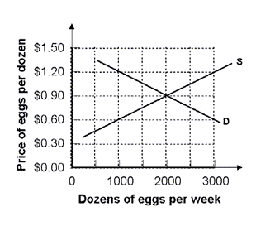
a. there is a shortage of 2,000 dozen eggs/week
b. there is a surplus of 2.000 dozen eggs/week
c. quantity demanded is just equal to quantity supplied
d. a shortage of 1,000 dozen eggs/week

7. Demand and supply are initially D and S1. Which of the following best describes the effect of a $.50 per pound tariff on Danish hens imported into the US.

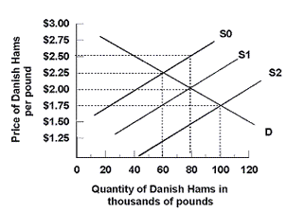
a. supply shifts from S1 to S2; quantity sold rises to 100 thousand pounds and price paid by consumers declines to 1.75 pd
b. neither supply nor demand shift, but price paid by consumers declines to $1.50 a pound while quantity sold remains at 80 a pound
c. supply shifts from S1 to S0; quantity sold declines to 60 thousand pounds and price paid by consumers rises to $2.50/pound
d. supply sifts from S1 to S0; quantity sold declines to 60 thousand pounds and price paid by consumers rises to $2.25 pound

8. Suppose that the following table shows the supply and demand schedules for Arabian light crude oil on the free market:

Price/Dollars barrel Quantity Demanded Quantity Supplied

26 14 10
27 13 11
28 12 12
29 11 13
30 10 14

Given the information in the table, the only price at which there is neither shortage nor surplus is:

9. In 2004 Taiwan news online reports that demand for healthy kidneys is high in both India and Nepal. But it is also illegal to buy or sell organs. Despite the legal and social disapproval, there is an illegal market for organs. Assuming the legal and social disapproval does not influence sellers but discourages buyers from seeking organs, the disapproval will.
a. raise price and raise quantity
b. raise price but lower quantity
c. lower price but raise quantity
d. lower price and lower quanity

10. The graph depicts a third party payer market for prescription drugs. If the co payment is $2 per pill, what will be the total market expenditures on prescription drugs?

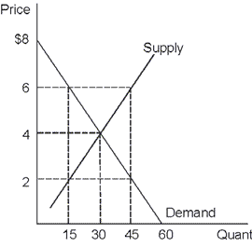

11. Compute the approximate elasticity of demand from the following data:
Initial Situation: Price: $23 Quantity: 11.5
New Situation: Price: $20 Quantity: 13.5

a. .87
b. 1.15
c. 1.5
d. 5.0

12. For substitutes:
a. cross price elasticity of demand can be any positive value.
b. cross price elasticity of demand can be any value less than one.
c. price elasticity of demand can be any positive value.
d. Cross price elasticity of demand can be a negative value

13. Refer to the graph. Between points A and B, demand is:

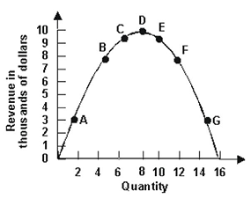
a. inelastic
b. elastic
c. unit elastic
d. perfectly elastic

14. Refer to the graph of demand curve below.
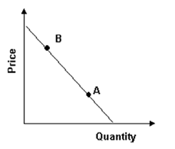
Which of the following is true?
a. point B is more elastic that point A
b. point A is more elastic than point B
c. Points A and B have equal elasticity
d. one can not say anything about the elasticity without more information

15. Compared to the elasticity of demand for off peak trains, one would expect elasticity of demand for peak time trains to be:
a. greater
b. less
c. unrelated
d. the same

16. Refer to the table. Between $1.60 and $1.80, demand is:
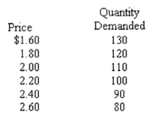

a. elastic
b. unit elastic
c. inelastic
d. perfectly elastic

17. The approximate elasticity of demand at point C is:

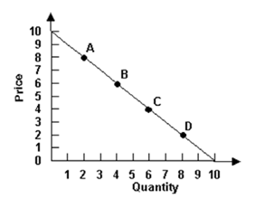

a. 2
b. 1
c. 2/3
d. 3/2

18. At which point is elasticity one?

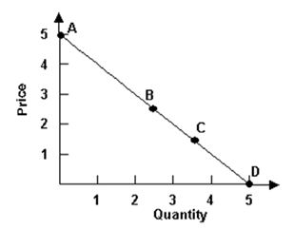
19. Susan’s price elasticity of restaurant meals is 2.27. If the price of a restaurant meal falls by 2% then the quantity of restaurant meals Susan demands will:

a. increase by 2.27%
b. fall by 2.27%
c. increase by 4.54%
d. increase by 22.7%

20. Refer to the graph. An effective price ceiling at $3 causes consumer surplus to:

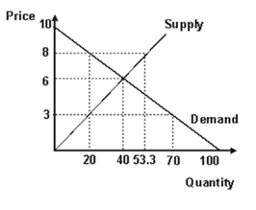
a. increase from 80 to 20
b. fall from 110 to 80
c. increase from 120 to 130
d. fall from 130 to 120

21. Refer to the graph, Initially the market is in equilibrium with price equal to $26 and quantity equal to 100. As a result of a per unit tax imposed by the government, the supply curve shifts from S0 to S1. The effect of the tax is to:
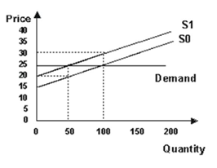

a. give government tax revenues of $100
b. give government tax revenues of $400
c. reduce producer surplus by $375
d. reduce producer surplus by $400

22. If the supply curve is perfectly elastic the burden of a tax on suppliers is borne:

a. entirely by the suppliers
b. entirely by the consumers
c. mostly by the suppliers and partly by the consumers, if the demand curve is inelastic
d. mostly by the suppliers and partly by the consumers, if the demand curve is elastic

23. Given the same price elasticity of supply, sellers would be able to pass along the smallest portion of a 10% tax on which item?

a. beef with a price elasticity of demand of .62
b. pork with a price elasticity of demand of .73
c. chicken with a price elasticity of demand of .32
d. fish with a price elasticity of demand of .12

24. Refer to the graph. Assume the market is initially in equilibrium at point j in the graph, but the imposition of a per unit tax or this product shifts the supply curve up from S0 to S1. The effect of the tax is to raise equilibrium price from:

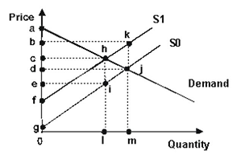
a. d to b
b. d to c
c. c to b
d. e to c

25. Refer to the graphs that show indifference curve analysis with the associated demand curves. The best explanation for a movement from point D to point F is:

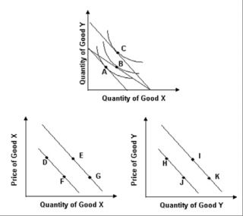

a. an outward rotation of the budget constraint along the X axis, allowing the consumer to move from point A to point B
b. a parallel shift of the budget constraint, allowing the consumer to move from point A to point C.

c. an inward rotation of the budget constraint along the X axis, forcing the consumer to move from point B to point A.
d. an outward rotation of the budget constraint along the Y axis, allowing the consumer to move from point B to point C

26. Jason is faced with two choices: A BMW costs $40,000 giving him an additional 800 units of utility and a laser printer for his computer costing $1000 giving him an additional 25 units of utility. Rational choice theory would predict that he would choose:

a. to purchase the BMW
b. to purchase the laser printer.
c. It is impossible to choose because the goods have different prices
d. It is impossible to choose because BMW's and laser printers are fundamentally different goods with different purposes

27. Suppose Paul has chosen a combination of two goods, A and B, such that marginal utility per dollar spent for good A (MUA/PA) is .6 and the marginal utility per dollar spent for good B (MUB/PB) is 1. To increase utility with the same amount of money Paul should

a. increase the number of B consumed and decrease the number of A consumed.
b. increase the number of A consumed and decrease the number of B consumed
c. increase the number of both A and B consumed
d. do nothing. He cannot increase total utility

28. Refer to the graph. The diagram demonstrates that an increase in the price of soda will
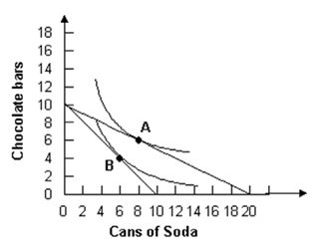
a. raise the quantity demanded of soda
b. reduce the quantity demanded of soda
c. raise the quantity demanded of chocolate bars
c. rasie the consumers available income

29. the utility gained from eating one slice of pizza is 30 and the utility gained from eating a second slice of pizza is 20. From this we know:

a. the marginal utility of the second slice of pizza is 60
b. the total utility of the second slice of pizza is 50
c. the marginal utility of the second slice of pizze is 20
d. there is not enough information to compute the marginal utility

30. Refer to the graph. If this monopolist were forced to set price equal to average cost, it would charge a price of
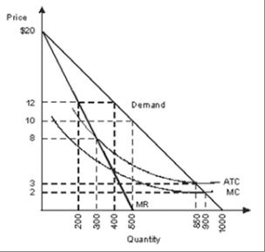
a. $2
b. $3
c. $8
d. $12

31. the demand curve for a perfect competitor is equal to its:

a. marginal cost curve
b. marginal revenue curve
c. average total cost curve
d. average fixed cost curve

32. Refer to the graphs depicting a perfectly competitive market and firm in a constant cost industry. If market demand increases from D0 to D1, in the long run:
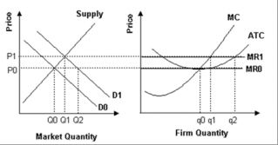

a. new firms will enter this market and price will return to P0
b. new firms will enter this market and price will remain at P1
c. some firms will exit this market and price will return to P0
d. some firms will exit this market and price will remain at P1

33. A perfectly competitive firm in the long run earns:
a. positive economic profits but zero normal profits
b. positive normal profits and zero economic profits
c. positive economic profits and positive normal profits
d. zero economic profits and zero normal profits

34. Refer to the graph. The welfare loss of monopoly is:
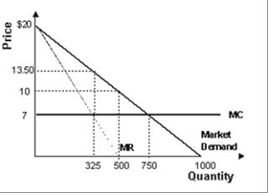
a. 1,137.5
b. 1,381.25
c. 2,112.5
d. 2,762.5

35. Refer to the graph. Assuming that the monopoly maximizes profit it will earn profits of:
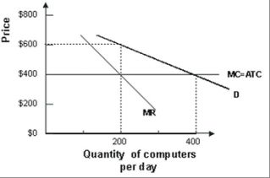
a. 8,000 per day
b. 20,000 per day
c. 40,000 per day
d. 160,00 per day

36. refer to the graph. If this monopolist charges a price of $8 for its product it:
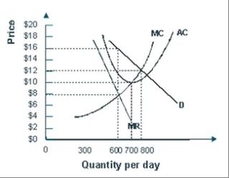
a. maximizes profit
b. incur losses
c. earns zero economic profits
d. can increase profits by increasing output

37. Patients have the most negative effect on consumers when

a. demand is inelastic
b. demand is elastic
c. marginal cost is high
d. marginal cost is low

37. In 2000, Amazon.com tested "dynamic pricing." Dynamic pricing would allow a web site to use the personal information collected on a customer, such as income or location, to individualize the price of a product for each customer. Economists consider this type of pricing to be an example of:

a. consumer sovereignty
b. producer sovereignty
c. price discrimination
d. price gouging

38. refer to the graph. If market price increases from $5 per unit to $6 per unit, a profit maximizing perfectly competitive firm will:
a. increase output from 650 to 750
b. decrease output from 750 to 650
c. continue to produce 650 units
d. produce 850 units of output

39. At the equilibrium output for a monopolistic competitor:
a. Price equals marginal cost equals marginal revenue
b. Price equals average total cost equals marginal revenue
c. marginal costs equals marginal revenue equals average total costs
d. price equals average total cost and marginal cost equals marginal revenue

40. The top four firms in the industry have 10 percent, 8 percent, 8 percent, and 6 percent of the market. The Herfindahl index of this market is closest to which of the following?

a. 8
b. 32
c. 66
d. 264

41. A market structure is which there a few interdependent firms is called
a. monopolistic competition
b. monopoly
c. oligopoly
d. perfect competition

42. Refer to the graph that shows an oligopolist facing a kinked demand curve. The firm will not increase price when marginal costs fluctuate between which two points
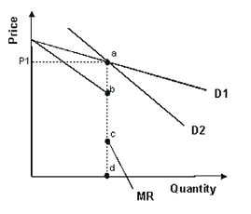
a. a and b
b. b and c
c. c and d
d. a and d

43. Suppose an oligopolistic firm assumes that its rivals will ignore a price increase but match a price cut. In this case the firm perceives its demand curve to be

a. kinked, being steeper above the going price than below
b. kinked, being steeper below the going price than above
c. linear, being less elastic at lower prices
d. linear, being more elastic at higher prices

44. refer to the graph above depicting a monopolistically competitive firm. The marginal revenue curve is represented by curve.
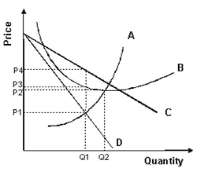
a. a.
b. b.
c. c
d. d

45. According to contestable market theory:

a. barriers to entry are much more important than market structure in determining the degree of price competition in an industry
b. barriers to entry are much less important than market structure in determining the degree of price competition in an industry
c. barriers to entry and market structure are both important in determining the degree of price competition in an industry
d. neither barriers to entry nor market structure affect the degree of price competition in an industry

46. Because a monopolistic competitor has some monopoly power, advertising to increase that monopoly power makes sense as long as

a. the marginal benefit of advertising is positive
b. the marginal benefit of advertising is negative
c. the marginal benefit of advertising exceeds the marginal cost of advertising
d. the marginal cost of advertising exceeds the marginal benefit of advertising

47. refer to the graph depicting a monopolistically competitive firm. According to the graph, economic profit is currently:
a. impossible to determine
b. positive
c. negative
d. zero

48. refer to graph. Say that there is a negative externality associated with the production of the good depicted. The marginal social cost from consuming this good at the competitive equilibrium output level is:
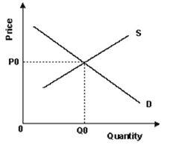
a. either greater than or less than P0, depending on the elasticities of supply and demand
b. greater than P0
c. less than P0
d. equal to P0

49. The perfectly competitive output is Pareto-optimal because at this output level
a. total cost to society equals the total benefit
b. marginal cost to society equals the marginal benefit
c. marginal cost to society is minimized
d. marginal benefit to society is maximized

50. In November 2004, the Environment Ministry in Japan proposed a new carbon tax in order to meet Japan's obligations to reduce carbon dioxide emissions under the Kyoto Treaty. The tax would be levied on producers and importers of fossil fuels and raise the cost of using fossil fuels. How do most economists view a tax such as this?

a. they prefer direct regulation to taxes because taxes create deadweight loss
b. they prefer voluntary programs to taxes because they reduce the role of compulsion
c. they do not believe any government intervention is necessary because the invisible hand of the market will correct the problem
d. they support taxes on pollution as a way of making decision makers consider all costs

51. A rightward shift of the marginal social benefit curve for pollution control
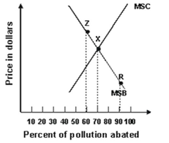
a. has no effect on the efficient percentage reduction in polluting emissions
b. makes it efficient to spend more on pollution abatement
c. makes it efficient to spend less on pollution abatement
d. makes pollution abatement cheaper

52. Some policies that may be implanted to combat global wqrning will

a. aid consumers who will have lower electric bills
b. aid farmers who produce corn but do little to combat global warming
c. aid farmers who produce corn for ethanol and thus substantially reduce global warming
d. aid poor people by reducing fossil fuel use rates

53. A primary justification for state-subsidization of higher education is that a society with better educated individuals will result in better laws, voting, and other social benefits. In a review of a book on higher education by Richard Vedder, John McGinnis writes that "Mr. Vedder ingeniously shows that the states that have spent the most on higher education in the past 25 years have experienced the least economic growth." This argues against higher education as:

a. having positive externalities
b. having negative externalities
c. being a non excludable service
d. having problems of adverse selection

54. All of the following are justifications for government intervention except:

a. too much competition
b. informational problems
c. externalities
d. public goods

55. The point on the graph corresponding to the socially optimal output per year and the price sellers must receive to make that amount available is shown by point:
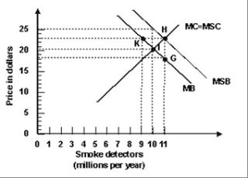
a. G
b. H
c. I
d. K

56. The efficient amount of pollution control is:

a. the amount for which the total social benefit equals the total social cost of pollution
b. the amount for which the marginal social benefit equals the marginal social cost of pollution
c. always zero
d. always 100% abatement

57. If a negative externality exists in the market for dirt bikes and that market is perfectly competitive:

a. less than the efficient output of dir bikes will be produced
b. the price of dirt bikes exceeds the marginal social cost
c. the price of dirt bikes equals the marginal social cost
d. the price of dirt bikes is less than the marginal social cost

58. An import quota does what?

a. decrease the price of the imported good to the consumer
b. increases the price of the domestic good to the consumer
c. redistributes income from domestic producers to domestic consumers
d. decreases the price received by the foreign producer

59. the text refers to the type of comparative advantage that is can be gained or lost because of changes in skills of workers or types of capital as:

a. unstable comparative advantage
b. transferable comparative advantage
c. non-equilbrium comparative advantage
d. temporary comparative advantage

60. Isolationism, a policy of trying to minimize a nations political and economic interactions with the rest of the world,
a. has always been key part of American politics
b. was important until the late 19th century and then declined
c. rose in America in the late 19th century and was an important political element until WWII
d. rose to importance in the US after WWII

61. A widget has an opportunity cost of 4 wadgets in Saudi Arabia and 2 wadgets in the United States. Given these opportunity costs, you would suggest that:

a. Saudi Arabia specialize in widgets and the US in wadgets
b. no trade should take place
c. Saudi Arabia specialize in wadgets and the US in widgets
d. both countries produce an equal amount of each

62. When Ross Perot ran for president as a third party candidate in 1992, he argued that free trade with Mexico would result in massive job losses in the U.S. because Mexican wages were so low. Which of the following is the best explanation of why few economists agreed with Perot?

a. Economists did not believe that any jobs would be lost in the U.S.
b. Economists believed that even though the U.S. unemployment rate would rise, that rise would be offset by an abundance of cheaper goods.
c. Although economists agreed that in some areas the U.S. would lose jobs, they expected that the U.S. would gain jobs in other areas.
d. Although economists predicted that unemployment would rise, the increased profits of corporations would raise stock prices enough to compensate for the lost jobs.

63. Assume that in Canada the opportunity cost of producing 1 television set is 2 bushels of wheat. Assume that in the U.S. the opportunity cost of producing 1 bushel of wheat is 2 television sets. If these two countries specialize according to comparative advantage and then trade with one another, then:

a. Canada will import both televisions and wheat.
b. Canada will import wheat and export televisions.
c. the U.S. will import wheat and export televisions.
d. the U.S. will import both televisions and wheat.

64. In the early 2000s the WTO authorized several countries to impose about $150 million in trade sanctions against the United States in retaliation for a U.S. import law that the WTO ruled to be illegal. The WTO that issued this ruling against the United States is known as

a. Wage Tariff Objective
b. World Trade Organization
c. Wealth Technology Order
d. Welfare Tax Order

65. Most economists:

a. oppose free trade
b. favor free trade
c. have no opinion on free trade
d. would prefer to have no trade with other nations

66. Gains from trade:
a. tend to be greater for large countries than for small ones
b. tend to be smaller for countries producing goods with economies of scale
c. exist only when a country has an absolute advantage in at least one product
d. accrue primarily to traders when entry is limited

67. From this we can conclude:

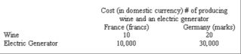

a. France has a comparative advantage in both goods
b. France has a comparative advantage in wine and Germany has a comparative advantage in electric generators
c. Germany has comparative advantage in wine and France has a comparative advantage in electric generators
d. Germany has a comparative advantage in both goods.

68. Waste produced by a power plant that harms local fishing industries is an example of:
a. demerit good
b. private good
c. limited liability
d. externality

69. Based on scientific nutritional studies,in most countries income of $1 a day does not provide sufficient food, shelter and clothing to live. Under these conditions the medical risk of death is high. This statement is:
a. normative
b. subjective statement
c. art of economics statement
d. objective statement

70. Ina feudalist society, in comparison with mercantilism:
a. merchants play a more important political role than serfs
b. tradition plays a more important role than the government
c. government plays a large role in determining the what, how, and for whom decisions
d. markets make the central economic decisions

