I need some help solving the following problem. I’m unsure on the steps to solve.

1, Determine the zero- force members in each truss

(a)

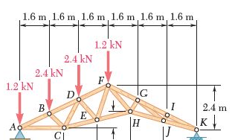
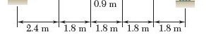

(b)
