Introduction to Open Systems Theory
I need help in writing a 2 to 3 page paper on Introduction to Open Systems Theory. I need assistance in getting started with this assignment due to being totally lost.

This assignment involves participating in a simulation exercise. Unlike cases, which are static, simulations are interactive and you can see the results of your decisions. What's more, you can repeat the simulation to improve the quality of your decisions.
While many simulations focus on just one general area of management (e.g. supply chain management or leadership), I have selected one that integrates several areas. In particular, you will be looking at income statements and sales reports. You will be making decisions about production, pricing, and investment.
The first step is to assist me in coming up with a strategy for how you will make these decisions. I don't want you to run the simulation yet! We will be following the following sequence:
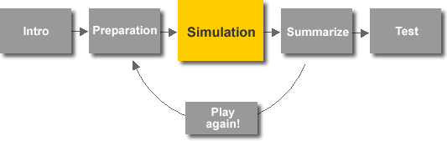
The simulation itself is short, so we will have the opportunity to repeat the above sequence three times.
For this assignment:
- Access the simulation site (Click here). We will be using the PDA Sim
- Read the introduction, and study the Financials and the Market Information. Review the Decisions you will be asked to make, BUT DO NOT ENTER ANY DECISIONS! (If you have difficulty with impulse control, try one of the other simulations!)
- In a two to three page paper, describe the strategy that you will use over the four years of the simulation, and defend why you think that strategy will work. In doing this you will want to consider what ratios will give you the information you need to make the best decisions. There are numerous ratios you can calculate with the data you have. First, you need to determine what types of ratios are going to be relevant to you. Obviously debt or liquidity ratios are not going to be germane to this simulation. You are going to want to look at ratios that measure manufacturing efficiency and profitability. Some you will want to use to compare the entire firm's performance over time, others can best be used when applied to comparing the three products' performance or profitability. Begin by looking at

    - unit price
    - unit cost
    - average revenue per unit
    - break even
Explain what these ratios tell you and how you can use them to plan and evaluate the effectiveness of your strategy. You will definitely need to use additional ratios that will give you more or better information - but at a minimum, these must be addressed in your paper.
You may append supporting materials, such as data tables and references. Be sure to EXPLICITLY draw on concepts and theories from some of the courses throughout the Business MBA program.
Hints for success!
For this assignment, you are being asked to make business decisions under conditions of incomplete information and uncertainty. To do so, you will need to make assumptions based on the MBA program about how markets operate. Thus your strategies in approaching this decision need to rely on models, ratio analysis, and theories from such classes as Economics, Finance, Accounting, Marketing, Strategy, and Quantitative Analysis. In addition, the simulation will give you some additional market information.
Be sure to "think like an MBA" and use the financial data that you are given. You will have to crunch some numbers and present your data analysis professionally by creating a few simple tables, charts and graphs.
It is necessary to make specific recommendations as to any pricing changes or allocations to R&D. (Drop the price of model X? By how much?) Your recommendations must make sense given your analysis of the market and chosen strategy.
It may not be the answer to the meaning of life, but this tutorial will help you figure out how to get started if you are totally lost. Click here, and thank Dr. Jack Elson for providing this primer on stuff you should remember - but probably forgot!

