Directions | Points
The files must be named as below:  Buttons.java  Ensure you include ALL files required to make your program compile and run.  I would like to see your .java files only.  Proper coding conventions required the first letter of the class start with a capital letter and the first letter of each additional word start with a capital letter. | 4
Basic Requirements  Write a complete program named Buttons that implements a window with three buttons – left, blue, and reset. When the left button is clicked, the window’s contents (the three buttons) shifts left. When the blue button is clicked, the window’s background color changes to blue. When the reset button is clicked, the window’s contents shifts back to the original center alignment and the window’s background color changes back to its original color.  In implementing the reset functionality, don’t try to figure out a color constant that’s used for the window’s original color value. That’s counterproductive because the color might be different on different computers. Instead, retrieve and save the window’s original color and then when the color needs to be reset, use that saved original color value.  Original display:  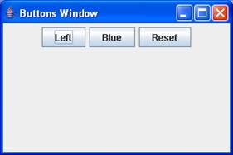  After Left button is clicked:  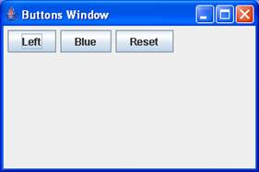  After Blue button is clicked:  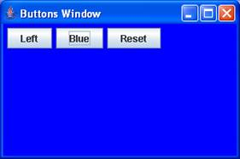  After Reset button is clicked:  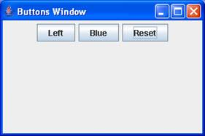  As always:  • Limit your use of class variables and instance variables – only use them if appropriate.  • Use appropriate modifiers for your methods. The modifiers we’ve discussed are private, public, protected, static, and final.  • Use helping methods if appropriate.  • Mimic the sample session precisely. In particular, note the window’s title, the window’s size, and the positions of components.  You can get full credit for completing this section only. | 72
Upload your page to the Dropbox.  NOTE: Complete your activity and submit it to the Dropbox in eCollege | 4
Total Points | 80

