Colonel Electric is a large company that produces lightbulbs and other electrical products. One particular lightbulb is supposed to have an average life of about 1,000 hours before it burns out. Periodically the company will test 5 of these and measure the average time before these burn out. The following table gives the results of 10 such samples:
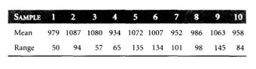
(a) What is the overall average of these means? What is the average range?
(b) What are the upper and lower control limits for a 99.7% control chart for the mean?
(c) Does this process appear to be in control? Explain.

