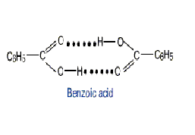
In nonpolar solvents, benzoic acid tends to dimerize by forming hydrogen bonds between the carboxylic acid groups

a. At T = 298K in benzene, the equilibrium constant for the dissociation of the dimer

(C₆H₅COOH)₂ 2 C₆H₅COOH

has the value K_{c} = 2.60 x 10⁻². If 0.250 moles of benzoic acid are dissolved in 1.00 L of benzene at this temperature, what are the molar concentrations of the monomer and dimer once equilibrium is established?

b. We can estimate the ΔHº for this reaction as +24.0 kJ.mol⁻¹, which is twice the energy of a typical hydrogen bond. At what temperature would the solution consist of equimolar amounts of monomer and dimer?

Hint: Be careful with stoichiometry in part b. The total amount of benzoic acid is 0.250 moles in 1.00 L and there are 2 moles of benzoic acid per mole of dimer. In other words, do not set the monomer and dimer concentrations equal to 0.250/2 = 0.125 M.

