Data  
Smokers:            x-bar1= 17.5   n1 = 16   s1-squared = 4.4752  
Non-Smokers:    x-bar2= 12.4   n2 =   9   s2 squared = 4.8492  
                           alpha = .05  
  
Calculation of Pooled Variance:  
  
        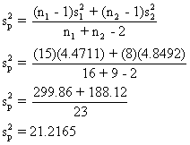  
 Assumptions

* independent random samples
* normal distribution of the populations
* population variances are equal

Hypotheses  
  
        H0 :  mu1  less than or equal to mu2  
        HA :  mu1 > mu2   
  
Test statistic  
  
        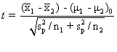  
        (a) Distribution of test statistic  
  
If the assumptions are met and H0 is true, the test statistic is distributed as Student's t distribution with 23 degrees of freedom.  
  
        (b) Decision rule  
  
With alpha = .05 and df = 23, the critical value of *t* is 1.7139.  We reject H0 if t > 1.7139.  
  
Calculation of test statistic  
  
        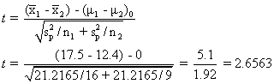  
   
 Statistical decision  
  
Reject H0 because 2.6563 > 1.7139.  
  
Conclusion  
  
On the basis of the data, we conclude that mu1> mu2.  
  
Actual values  
    t = 2.6558  
    p = .014