Question 13: The Nelson Company experienced the following costs in 2007:
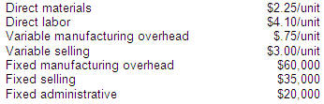
During 2007 the company manufactured 120,000 units and sold 145,000 units. Assume the same unit costs in all years. Total variable costs on the company’s 2007 contribution income statement will be:
 | A | $1,464,500
 | B | $1,029,500
 | C | $1,102,000
 | D | $1,537,000

Question 14: During the past year the Carver Company manufactured 25,000 units and sold 20,000 units. Production costs during the year were as follows:
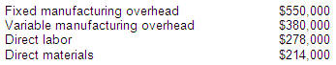
Sales totaled $1,270,000, variable selling and administrative costs totaled $110,000, and fixed selling and administrative costs totaled $170,000. There were no units in beginning inventory.
The contribution margin per unit is:
 | A | $6.62
 | B | $23.12
 | C | $28.62
 | D | $24.22

Question 15: Three costs incurred by Jolie Company are summarized below:
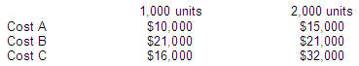
Which of these costs are variable?
 | A | A, B, and C.
 | B | A and C.
 | C | A only.
 | D | C only.

Question 16: Earth Company makes 2 products, Wind and Fire. Wind has a Contribution Margin per unit of $6.00 and Fire has a contribution margin per unit of $11.00. Earth Company has annual fixed costs of $290,000.
Assume that products Wind and Fire are sold in a 3:1 mix (3 units of Wind are sold for each unit of Fire). How many units of each must be sold to break even?
 | A | 30,000 Wind; 10,000 Fire
 | B | 7,500 Wind; 2,500 Fire
 | C | 18,913 Wind; 6,304 Fire
 | D | 40,000 Wind; 0 Fire

Question 17: During 2007, Bonzai Corporation reported total revenues of $891,640 and profit of $91,486. Fixed costs were $332,043, and 44,582 units were sold. If costs and prices are expected to stay the same in 2008, and Bonzai expects to sell 50,000 units, what will be the company’s budgeted profit?
 | A | $142,957
 | B | $525,000
 | C | $667,957
 | D | $475,000

Question 18: Comstat’s contribution income statement utilizing variable costing appears below:
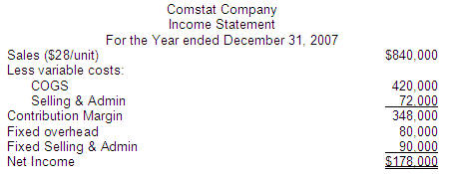
Comstat Company produced 40,000 units during the year. Variable and fixed production costs have remained constant the entire year. There were no beginning inventories.
The dollar value of the ending inventory using full costing will be:
 | A | $160,000
 | B | $186,500
 | C | $140,000
 | D | $164,000

