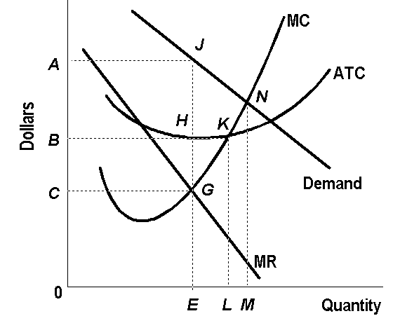

a. What is the firm’s Total Revenue?
b. What is the Total Cost?
c. What is the firm’s Total Profits?
d. If the above monopolist were to behave like a perfectly competitive firm (operating in the long run), determine its output.

