- A race car makes two and a half laps around a circular track in 3 mins. What is the car’s average angular speed?
Answer: - 0.087 rad/s
- A wheel of radius 1.5m rotates at a uniform speed. If a point on a rim of the wheel has a centripetal acceleration of 1.2m/s^2, what is the point’s tangential speed?
Answer: - 1.3m/s

- A block of mass “m” slides down an inclined plane into a loop-the-loop of radius “r”.

- Neglecting friction, what is the minimum speed the block must have at the highest point of the loop in order to stay in the loop? {Hint: what force must act on the block at the top of the loop to keep the block on the circular path?}
- At what vertical height on the inclined plane (in terms of the radius of the loop) must the block be released if it is to have the required minimum speed at the top of the loop?
Answer: - (a) v = sqrt rg (b) h = 5/2 r

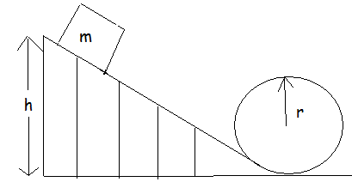

- A pendulum swinging in a circular arc under the influence of gravity, as shown, has both centripetal and tangential components of acceleration.
- If a pendulum bob has a speed of 2.7 m/s when the cord makes an angle of @ = 15 degree with the vertical, what are the magnitudes of the components at this time?
- Where is the centripetal acceleration a maximum? What is the value of tangential acceleration at that location?

Answer: - (a) at = 2.5 m/s^2 and ac = 9.7m/s^2 (b) At the lowest point of the swing , since v is maximum there and at = 0 because the velocity is not changing.
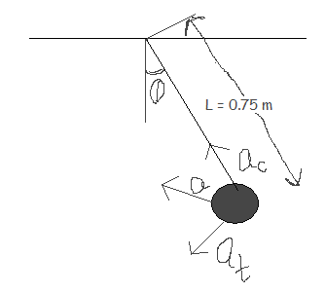

- During the Apollo lunar explorations of the late 1960’s and the early 1970’s, the main section of the spaceship remained in orbit about the moon with one astronaut in it while the other two astronauts descended to the surface in the landing module. If the main section orbited about 50 mi above the lunar surface, determine that sections centripetal acceleration?
Answer: - 1.5 m/s^2

