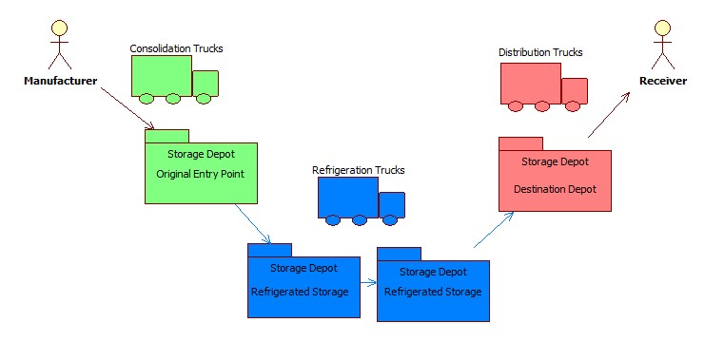
The Parts shown in green are the ones of the Food Processing industry. The Blue ones are the logistics provider, as you can see from the figure the logistics might involve multiple transports and multiple intermediate storages, so it is the responsibility of the logistics provider to ensure that packages are handled at proper temperature. Storage is provided by the logistics company at various strategic points, and the package is finally delivered to the distributor. Then the distributor delivers it to the end consumers based on the orders.

In another case, the packages are left at the storage itself; the distributors will pick the food packages from the storage on a need basis, thus utilizing the storage provided by the logistics itself.

Due to the interactions between different processes and multiple interventions during transport, there are lot of possibilities of food package getting spoilt and having bad quality which can harm the consumers. Finally there is no point in blaming the processes for the failure, it is the end consumer who will get affected because of bad quality. Hence this is a good use case for the study of a monitoring system for the entire supply chain to assess the quality of the food package. Here, we leverage the RFID concepts in the food supply chain and propose a system for monitoring temperature and humidity.

Logistics Model

The various logistics models are described in the figure below,

