Chapter 9:
22. Arithmetic and Geometric Returns A stock has had returns of 29 percent, 14 percent, 23 percent, −8 percent, 9 percent, and −14 percent over the last six years. What are the arithmetic and geometric returns for the stock?

Chapter 11
3.
Factors Models Suppose a factor model is appropriate to describe the returns on a stock. The current expected return on the stock is 10.5 percent. Information about those factors is presented in the following chart:
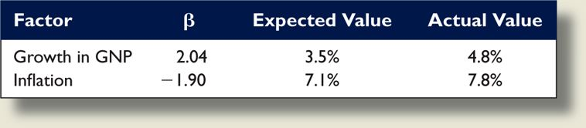
a. What is the systematic risk of the stock return?
b. The firm announced that its market share had unexpectedly increased from 23 percent to 27 percent. Investors know from past experience that the stock return will increase by 0.36 percent for every 1 percent increase in its market share. What is the unsystematic risk of the stock?
c. What is the total return on this stock?

5.
Multifactor Models Suppose stock returns can be explained by a two-factor model. The firm-specific risks for all stocks are independent. The following table shows the information for two diversified portfolios:
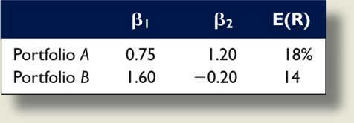
If the risk-free rate is 6 percent, what are the risk premiums for each factor in this model?

6.
Market Model The following three stocks are available in the market:
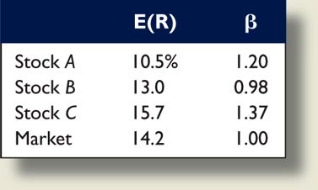
Assume the market model is valid.
a. Write the market model equation for each stock.
b. What is the return on a portfolio with weights of 30 percent stock A, 45 percent stock B, and 25 percent stock C?
c. Suppose the return on the market is 15 percent and there are no unsystematic surprises in the returns. What is the return on each stock? What is the return on the portfolio?

