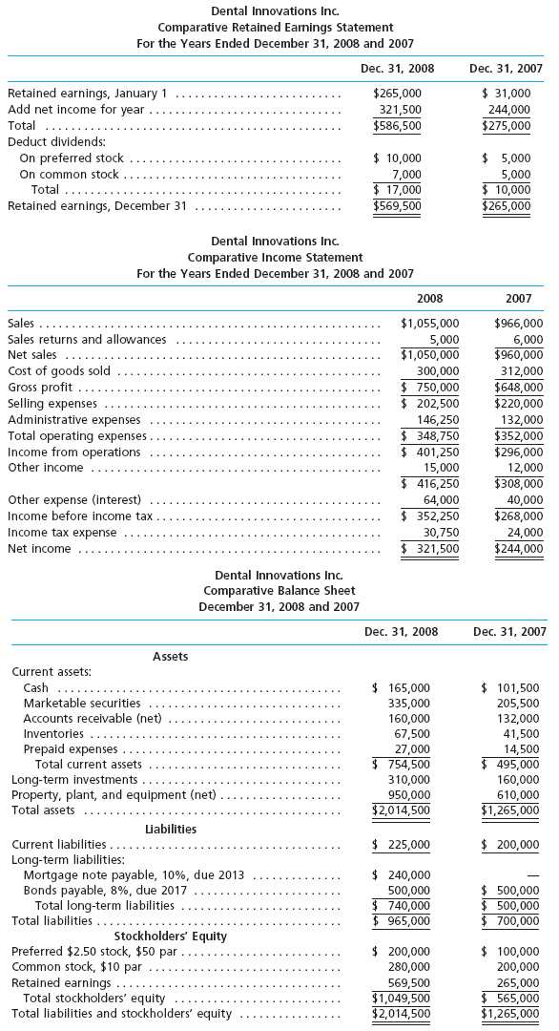
Determine the following measures for 2008, rounding to one decimal place:
1. Working capital
$
2. Current ratio
3. Quick ratio
4. Accounts receivable turnover
5. Number of days' sales in receivables
6. Inventory turnover
7. Number of days' sales in inventory
8. Ratio of fixed assets to long-term liabilities
9. Ratio of liabilities to stockholders' equity
10. Number of times interest charges earned
11. Number of times preferred dividends earned
12. Ratio of net sales to assets
13. Rate earned on total assets
%
14. Rate earned on stockholders' equity
%
15. Rate earned on common stockholders' equity
%
16. Earnings per share on common stock
$
17. Price-earnings ratio
18. Dividends per share of common stock
$
19. Dividend yield
%

