9. Calculating Returns and Variability You've observed the following returns on Mary Ann Data Corporation's stock over the past five years: 216 percent, 21 percent, 4 percent, 16 percent, and 19 percent.
a. What was the arithmetic average return on Mary Ann's stock over this five-year period?
b. What was the variance of Mary Ann's returns over this period? The standard deviation?
10. Calculating Real Returns and Risk Premiums In Problem 9, suppose the average inflation rate over this period was 4.2 percent and the average T-bill rate over the period was 5.1 percent.
a. What was the average real return on Mary Ann's stock?
b. What was the average nominal risk premium on Mary Ann's stock?
5. Calculating Expected Return Based on the following information, calculate the expected return:
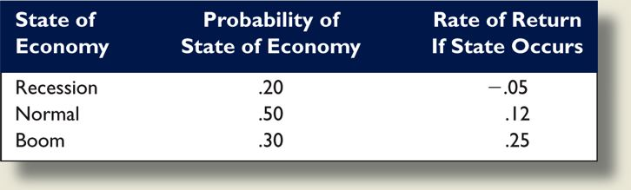

6. Calculating Returns and Standard Deviations Based on the following information, calculate the expected return and standard deviation for the two stocks:
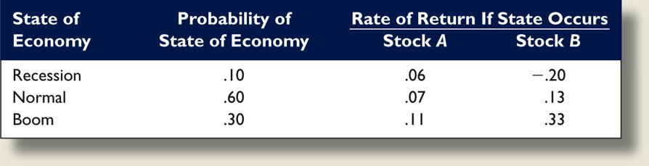
Discuss an overview of the measures of returns on various financial assets, and the various measures of the risk associated with the same assets. Develop the concept of portfolio and provide measures of portfolio risk and return. Analyze beta as a measure of relative risk of the stock and the impact of diversification on measuring risk.
Discuss the applications of portfolio theory, the concept of time value of money on financial management analysis.

