1.
Johansson Company developed the following static budget at the beginning of the company's accounting period:
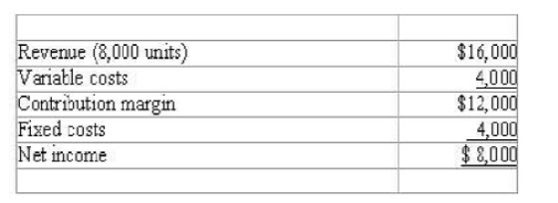
If actual production totals 8,400 units, the flexible budget would show variable costs of:
A) $16,400.
B) $ 4,000.
C) $ 4,100.
D) $4,200.
2.
Pace Company makes computer chips. Sam is manager of the company's maintenance department. Because his maintenance technicians are so well trained in maintaining expensive and sensitive circuit board stamping equipment, Sam has been authorized to contract to perform maintenance for outside customers. In this company, the maintenance department is likely organized as:
A) a cost center.
B) a revenue center.
C) a profit center.
D) an investment center.
3.
Which of the following would NOT be represented in the financing activities section of the statement of cash flows?
A) Purchased a new office building.
B) Purchased treasury stock.
C) Made installment payment on long-term note payable.
D) Issued preferred stock.
4.
A customary assumption in capital budgeting analysis is that:
A) the desired rate of return includes the effects of compounding.
B) the cash inflows generated by the investment are reinvested at the desired rate of return.
C) annual cash flows occur at the end of each period.
D) All of the above

5.
Lighthouse Tours provide seven-day guided tours along the New England coast. The company pays its guides a total of $100,000 per year. The average cost of supplies, lodging and food per customer is $500. The company expects a total of 500 customers during the period January - June, and a total of 1,500 customers from July through December. Lighthouse wants to earn $200 per customer. For promotional reasons the company desires to charge the same price throughout the year. Based on this information, what is the correct price per customer? (round to nearest dollar)
A) $550
B) $600
C) $750
D) $800
6.
If a company misclassifies a general, selling and administrative cost as a product cost in a period when production exceeds sales
A) net income will be understated.
B) total assets will be understated.
C) cash flow will be unaffected.
D) All of the above.
7.
Moore Company allocates overhead on the basis of direct labor hours. It allocates overhead costs of $6,400 to two different jobs as follows: Job 1: (10 hours) = $3,200 Job 2: (10 hours) = $3,200 Assume that, then, the production process for Job 1 was automated. Now Job 1 requires only 2 hours of direct labor but four hours of mechanical processing. As a result, total overhead increases to $8,500. With the change in the production process for job 1,
A) The amount of overhead assigned to each product will increase.
B) The amount of overhead assigned to Job 2 will increase.
C) The amount of overhead assigned to each product will decrease.
D) The amount of overhead assigned to Job 1 will increase.
8.
The following standard cost card is provided for Product Dolce2.
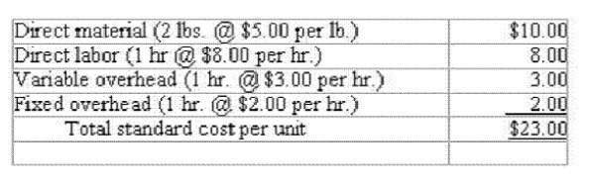
The fixed overhead rate is based on total budgeted fixed overhead of $12,000. During the period, the company produced and sold 5,800 units at the following costs.
Direct material 12,000 pounds @ $4.50 per pound
Direct labor 5,750 hours @ $8.00 per hour
Overhead $29,920 T
he standard manufacturing cost per unit is $23.00 while the actual manufacturing cost per unit was:
A) $23.71
B) $23.16
C) $22.40
D) Cannot be determined from the information provided
9.
Payment of cash for production workers' wages is:
A) an asset source transaction.
B) an asset exchange transaction.
C) an asset use transaction.
D) a claims exchange transaction.
10.
Standard cost systems facilitate the management practice known as:
A) management development.
B) management by exception.
C) just-in-time management.
D) managing by the numbers.
11.
Newton Company currently produces and sells 4,000 units of a product that has a contribution margin of $6 per unit. The company sells the product for a sales price of $20 per unit. Fixed costs are $18,000. The company is considering investing in new technology that would decrease the variable cost per unit to $8 per unit and double total fixed costs. The company expects the new technology to increase production and sales to 9,000 units of product. What sales price would have to be charged to earn a $90,000 target profit?
A) $22
B) $20
C) $18
D) $ 8
12.
Kritzberg Company sells a product at $60 per unit that has unit variable costs of $40. The company's break-even sales volume is $120,000. How much profit will the company make if it sells 4,000 units?
A) $240,000
B) $120,000
C) $ 40,000
D) $ 80,000
13.
The Mannix Company manufactures and sells two lines of china. During the most recent accounting period, the Faux line and the Traditional line sold 15,000 and 2,000 units, respectively. The company's most recent financial statements are shown below:
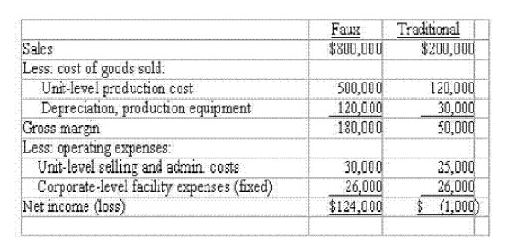
Based on this information, the company should:
A) eliminate the Traditional line because it is operating at a loss.
B) keep the Traditional line because it contributes $26,000 to total profitability.
C) keep the Traditional line because it contributes $55,000 to total profitability.
D) keep the Traditional line because it contributes $50,000 to total profitability.
14.
A manager refuses to replace an existing asset even though an extensive analysis indicates that replacement is desirable. One possible explanation for the manager's action is that:
A) a financial loss may be reported in the current period if the asset is replaced.
B) the manager is concerned that his or her superior may think that the original asset purchase was a mistake on the part of the manager.
C) the manager expects to be promoted or transferred in the near future and is concerned primarily about short-term performance.
D) All of the above
15.
For the year ended December 31, 2007, The Fell Company paid cash dividends of $13,000, paid cash for interest of $5,200, paid cash to suppliers of $7,500 and paid $17,000 to purchase equipment. Based on this information, the amount of cash used by investing activities for 2007 is:
A) $17,000.
B) $18,200.
C) $25,200.
D) $42,700.
16.
A materials requisition in a job-order cost system is used as a:
A) request form for getting the necessary materials from the materials store room.
B) a subsidiary account for recording the materials used on each job.
C) a source document for assigning costs to individual departments.
D) none of the above

17.
The following income statement was drawn from the annual report of Hurricane Company:
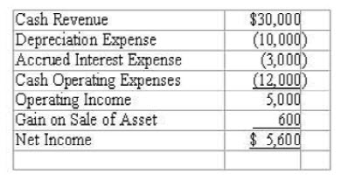
The amount of cash flow from operating activities is:
A) $18,600
B) $18,000
C) $13,000
D) $12,400
18.
All of the following factors should influence the decision to investigate a variance except:
A) Frequency of occurrence
B) Materiality of the variance amount
C) Capacity for management to control
D) Whether the variance is favorable or unfavorable
19.
Bruce Company's sales budget shows the following expected total sales:
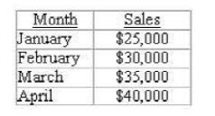
The company expects 70% of its sales to be on account (credit sales). Credit sales are collected as follows: 25% in the month of sale, 72% in the month following the sale with the remainder being uncollectible and written off in the month following the sale. The total cash inflows from the collection of receivables in April would be:
A) $18,200
B) $21,000
C) $24,640
D) $25,725
20.
An investment that costs $30,000 will produce annual cash flows of $10,000 for a period of 4 years. Given a desired rate of return of 8%, the investment will generate a (round to nearest whole dollar)
A) positive net present value of $33,121
B) positive net present value of $3,121
C) negative net present value of $33,121
D) negative net present value of $3,121
21.
Moore Company uses process costing. The following information was available for October:
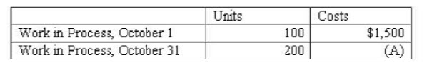
During October, 1,000 units were started, and costs incurred during the month were $18,500. Ending inventory was 50% complete. Based on the information given, (A) above would be what amount?
A) $ 2,000
B) $ 4,000
C) $1,500
D) $1,650
22.
Prater Company made a $100,000 investment in new machinery. Assuming the company's margin is 4%, what income will be earned if the investment generates $300,000 in additional sales?
A) $40,000.
B) $12,000.
C) $200,000.
D) none of the above.
23.
Robert is deciding whether to remain in the home he has lived in for the past ten years, which is located very near his work, or to move into a newer home that is located in the suburbs further from his job. The old house was purchased for $140,000 and has a market value of $200,000. The new home can be purchased for $275,000. Which of the following is not relevant to Robert's decision?
A) driving distance to work
B) cost of the new house
C) market value of the old house
D) cost of the old house
24.
Responsibility reports are prepared:
A) for senior level managers only.
B) only at the end of the accounting period.
C) to identify and punish managers who fail to control their costs.
D) for each manager who has control over revenue and expense items.
25.
Banks Industries has budgeted the following information for March:
If there is a cash shortage, the company borrows money from the bank. All cash is borrowed at the beginning of the month in $1,000 increments and interest is paid monthly at 1% on the first day of the following month. The company had no debt before March 1st. The shortage or surplus of cash before considering cash borrowed in March would be:
A) $8,000 shortage
B) $50,000 shortage
C) $58,000 shortage
D) $58,000 surplus
26.
Casters, Inc. normally produces between 150,000 and 175,000 units each year. Producing more than 175,000 units alters the company's cost structure. For example, fixed costs increase because more space must be rented, and additional supervisors must be hired. The production range between 150,000 and 175,000 is called the
A) differential range.
B) relevant range.
C) opportunity range.
D) leverage range.
27.
Conger Company recently implemented an activity-based-costing system. As a result of the ABC allocations, the cost of one of the company's products was determined to be above its current selling price. Due to competition, the company is unable to raise the price of this product. Which of the following options is most reasonable, assuming Conger employs a target costing strategy?
A) Target advertising to high income customers
B) Raise prices under the assumption that the company's competitors will follow suit
C) Use less expensive materials to make the product
D) Return to the old allocation method which produces a lower amount of estimated cost
28.
During its first year of operations, Martin Company paid $4,000 for direct materials and $8,500 for production workers' wages. Lease payments and utilities on the production facilities amounted to $7,500 while general, selling, and administrative expenses totaled $3,000. The company produced 5,000 units and sold 4,000 units at a price of $7.50 a unit. What was Martin's net income for the first year in operation?
A) $11,000
B) $7,000
C) $14,000
D) $20,000
29.
Expressing plans for a business in financial terms is commonly called:
A) master planning.
B) strategic planning.
C) budgeting.
D) operational planning.

30.
Kent Company had 800 units of product in its work in process inventory at the beginning of the period. During the period 3,000 additional units of product were started. At the end of the period there were 1,500 units of product in the work in process account. The ending work in process inventory was estimated to be 30% complete. The beginning work in process inventory had a balance of $2,000. There were $42,000 of product costs added to work in process during the period. The amount of cost in ending work in process inventory is:
A) $16,800.
B) $24,000.
C) $5,351.
D) $ 7,200.
31.
Production in 2007 for Stowe Snow Mobile was at its highest point in the month of June when 40 units were produced at a total cost of $600,000. The low point in production was in January when only 15 units were produced at a cost of $340,000. The company is preparing a budget for 2008 and needs to project expected fixed cost for the budget year. Using the high/low method, the projected amount of fixed cost per month is
A) $260,000
B) $240,000
C) $184,000
D) $ 10,400
32.
Select the correct statement from the following.
A) A fixed cost structure offers less risk (i.e., less earnings volatility) and higher opportunity for profitability than does a variable cost structure.
B) A variable cost structure offers less risk and higher opportunity for profitability than does a fixed cost structure.
C) A fixed cost structure offers greater risk but higher opportunity for profitability than does a variable cost structure.
D) A variable cost structure offers greater risk but higher opportunity for profitability than does a fixed cost structure.
33.
Select the correct statement regarding opportunity costs.
A) Opportunity costs need not be considered in decision making.
B) Opportunity costs represent sunk costs.
C) Opportunity costs are not recorded in the firm's financial accounting records.
D) All of the above are correct.
34.
Select the incorrect statement regarding postaudits of capital investment decisions.
A) A postaudit should be conducted at the end of the project.
B) The postaudit helps management determine whether a project that had been accepted should have been rejected.
C) A postaudit is not necessary for a capital investment selected using a technique that considers the time value of money.
D) The goal of a postaudit is to provide feedback that can be used to improve the accuracy of future capital investment decisions.
35.
St. Augustine Company is trying to decide which one of two contracts it will accept. The costs and revenues associated with each are listed below:
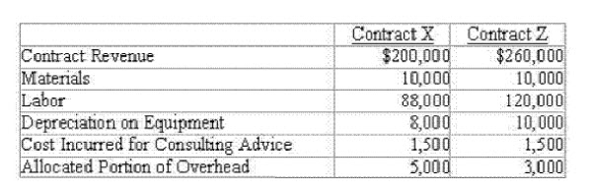
Which of these amount(s) is relevant for the selection of one contract over another?
A) Contract revenue and cost of materials
B) Materials, consulting advice and allocated overhead
C) Cost of consulting advice and allocated overhead
D) Contract revenue and labor costs
36.
The following information is provided by the Atlantic Company:
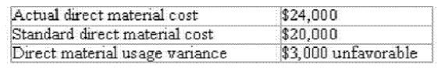
What is the direct material price variance?
A) $1,000 favorable
B) $1,000 unfavorable
C) $5,000 unfavorable
D) Not enough information is provided
37.
The preferred method for setting transfer prices generally is some form of:
A) price based on negotiation.
B) price based on market forces.
C) price based on historical costs.
D) price based on industry cost averages.
38.
The research and development department of Pepsi-Cola Company would likely be organized as:
A) a cost center.
B) a profit center.
C) a revenue center.
D) an investment center.

39.
The statement of cash flows would not disclose the effects of:
A) a 2-for-1 stock split.
B) a sale of equipment.
C) a purchase and immediate retirement of treasury stock.
D) cash dividends declared and paid.
40.
The Sukahara Company recorded the following costs of quality during the current period:
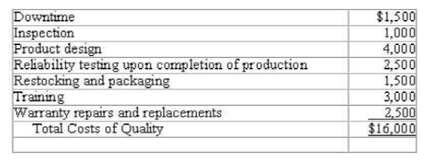
How much of the costs were prevention and appraisal costs?
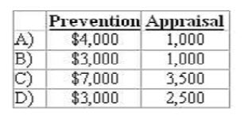
A) Item A
B) Item B
C) Item C
D) Item D
41.
The use of raw materials in production is:
A) an asset source transaction.
B) an asset exchange transaction.
C) an asset use transaction.
D) a claims exchange transaction.
42.
Wall Company incurred $30,000 of fixed cost and $40,000 of variable cost when 2,000 units of product were made and sold. If the company's volume doubles, the cost per unit will
A) stay the same.
B) double as well.
C) increase but will not double.
D) decrease.
43.
Weinger Company has developed the following budgeted income statement:
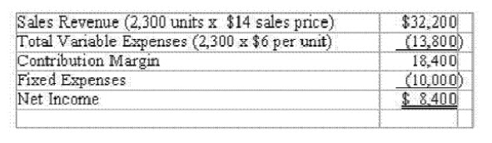
The company is experimenting with new engineering techniques and believes it can reduce variable cost to $4 per unit and significantly improve the product. The innovations would double fixed costs but the company expects to be able to increase sales to 3,000 units. If this strategy is pursued the company's budgeted net income will:
A) increase by $1,600
B) increase by $1,440
C) increase by $10,000
D) decrease by $4,400
44.
What amount of cash would result at the end of one year, if $17,000 is invested today and the rate of return is 10%?
A) $17,000
B) $18,530
C) $18,700
D) none of the above
45.
Which of the following statements concerning product costs versus general, selling, and administrative costs is true?
A) Product costs incurred during the period will always appear as inventory on the balance sheet.
B) General, selling, and administrative costs are always expensed when cash is paid.
C) Product costs may be divided between the balance sheet and income statement.
D) General, selling, and administrative costs sometimes appear as inventory on the balance sheet.
46.
Which of the following transactions would cause net income for the period to be lower?
A) Paid $1,600 cash for raw material cost
B) Paid administrative salaries of $2,500
C) Depreciated production equipment for $3,000
D) Purchased $5,000 of merchandise inventory
47.
Which of the following activity costs would not likely be included in a unit-level activity cost pool?
A) Indirect material
B) Indirect labor
C) Material handling costs
D) Machine-related utilities

48.
Which of the following budgets needs to be prepared prior to preparing a purchases budget?
A) Selling and administrative expense budget
B) Cash budget
C) Sales budget
D) All of the above
49.
Which of the following cash transactions would not be shown under operating activities on the statement of cash flows?
A) Cash paid for dividends
B) Cash paid for inventory
C) Interest revenue
D) Cash paid for interest
50.
Zoro, Inc. produces a product that has a variable cost of $6.00 per unit. The company's fixed costs are $30,000. The product sells for $10.00 a unit and the company desires to earn a $20,000 profit. What is the volume of sales in units required to achieve the target profit?
A) 5,000
B) 7,500
C) 8,333
D) 12,500

