The Dreskin Development Company is building two apartment complexes. It must decide how many units to construct in each complex subject to labor and material constraints. The profit generated for each apartment in the first complex is estimated at $900, for each apartment in the second complex, $1,500. A partial initial simplex tableau for Dreskin is given in the following table:
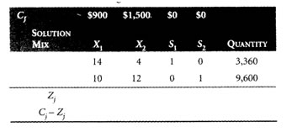
(a) Complete the initial tableau.
(b) Reconstruct the problem’s original constraints (excluding slack variables).
(c) Write the problem’s original objective function.
(d) What is the basis for the initial solution?
(e) Which variable should enter the solution at the next iteration?
(f) Which variable will leave the solution at the next iteration?
(g) How many units of the variable entering the solution next will be in the basis in the second tableau?
(h) How much will profit increase in the next solution?

