I have some of the answers in my textbook. But I need help understanding the steps to get the answer.
1. 30.4 in.

3. F= -( 1220 N)I ; M = ( 73.2 N x m) j -( 122.0 N x m) k .
- determine the perpendicular distance between cable EF and the line joining points A and D .
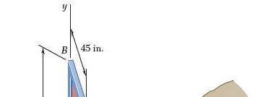
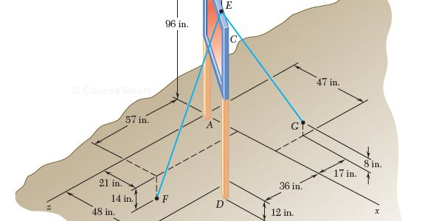

- A dirigible is tethered by a cable attached to its cabin at B . If the tension in the cable is 1040 N, replace the force exerted by the cable at B with an equivalent system formed by two parallel forces applied at A and C.
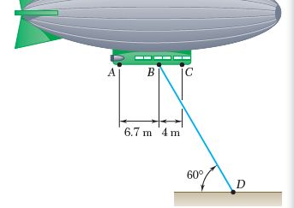
- An eccentric, compressive 1220- N force P is applied to the end of a cantilever beam. Replace P with an equivalent force- couple system at G.
