Money Supply

a) TR_{s} = TR_{d}
b) BR + NBR = RR + ER

c) TR_{s} = B_{f} + (OA - OL – Cur) + DWL
Where B_{f} = Treasury securities held by the Fed. This is the component that the Fed affects when it buys or sells Treasury securities in an open market operation (OMO).
d) TR_{d} = RR + ER = rr D + ER

Set TR_{d} = TR_{s} and subtract ER from both sides:
e) rr D = B_{f} + (OA - OL – Cur) + DWL – ER
f) D = 1/rr [B_{f} + (OA - OL – Cur) + DWL – ER]
Note: BR = DWL
NBR = B_{f} + (OA - OL – Cur)
g) D = 1/rr [NBR + BR – ER]

The equation above allows us to identify individual components which increase or decrease Deposits and, therefore the money supply.

h) M_{s} = Cur + D
= Cur + 1/rr [NBR + BR – ER]
= Cur + 1/rr [B_{f} + (OA - OL – Cur) + BR – ER]

OMO to achieve a lower target for federal funds rate:
↑ B_{f} ↑NBR ↑M_{s} ESM ↓ i.
Dynamic Open Market Operation – OMO planned to increase (or decrease) money supply and decrease (or increase) the federal funds rate.
Defensive Open Market Operation – OMO to offset an unwanted change in i (caused by a shock to money supply and/or money demand).
Money Demand
M_{d} = M_{d} (Y, i, C )
+, - , +
(Money demand increases with Y, decreases with i, and increases with the Collective Factor, C )
- Other things equal, the demand for money falls when C falls. C falls if:
    - Improvements in cash management technology are introduced.
    - The uncertainty of future income is reduced.
    - The relative risk of securities and real assets falls.
    - The relative maturity of securities falls.
    - The relative marketability of securities and real assets rises.
    - The relative liquidity of securities and real assets rises
- In our simplified model, individuals hold their wealth in either money or bonds:
M_{d} + B_{d} = Wealth.
As i increases (other things equal) individuals prefer to hold more of their wealth in bonds and less in money. Because i is the return on holding bonds, it is also the opportunity cost of holding money. Therefore, as i increases the quantity of money demanded decreases (money demand is downward sloping).

Changes in Y, Wealth, or C will shift money demand while a change in the interest rate causes a movement along the money demand curve.

Example 1: Shock = decrease in Money Supply.

Suppose the Fed is concerned about inflationary pressures in the economy and increases its target for the federal funds rate. The Fed would conduct a dynamic OMO—it would sell treasury securities to decrease NBR, decreasing deposits and the money supply:
↓ B_{f} ↓NBR ↓M_{s}, EDM and ↑ i
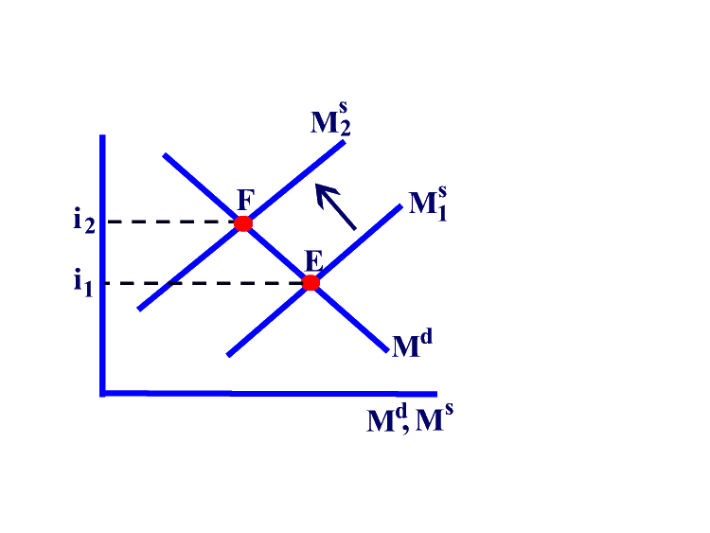
Example 2: Shock = decrease in Money Demand.

Suppose that there is a decrease in the demand for money caused by an increase in the relative liquidity of securities (meaning that the ease and speed of converting the securities to cash has increased and the public – households and firms—are willing to hold more securities and therefore less money). The Fed, however, wants to keep the interest rate at its current level. Show how the change in money demand would affect the interest rate and how the Fed would react to keep i constant.

A decrease in money demand will cause a downward shift of M_{d}, ESM and a decrease in the interest rate and a decrease in the quantity of M demanded (measured on the x-axis) to point F on the graph below. If the Fed wants to maintain the initial (higher) level of the interest rate, it will have to decrease NBR and the money supply. To do this, the Fed will sell treasury securities, B_{f} and NBR will decrease, and Deposits will decrease. The money supply curve shifts to the left resulting in EDM which will cause the interest rate to increase, restoring the initial level of i (now at point G). The lefttward shift of M_{s} causes a further decrease in M. The final level of i is unchanged but the level of M is lower.
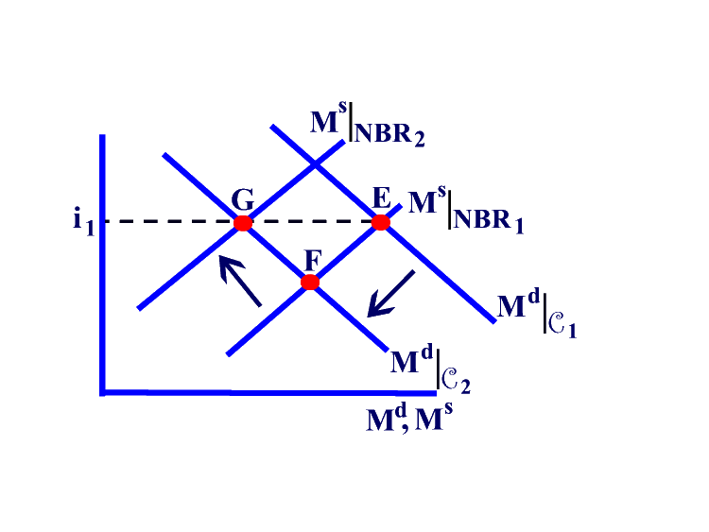

Example 3: Shock = Banks holding more ER (making fewer loans resulting in fewer Deposits).

Suppose that banks become more cautious. At every level of the interest rate, banks want to hold more ER, and make fewer loans.
- M_{s} = Cur + D
= Cur + 1/rr (NBR + BR – ER)
All else equal, when ER increase, money supply decreases causing a shift to the left of the Ms curve. There is EDM and i increases. ↑ ER ↓ D ↓M_{s} EDM ↑ i

