1. During the year Leyland Company completed 1,300 units of product. Ending inventory consisted of 400 units that were 50% complete. The total dollar cost associated with production of inventory was $45,000. The cost per equivalent whole unit would be which of the following? (Round all answers to the nearest whole penny.)
A) $26.00
B) $30.00
C) $34.61
D) $41.91
2. What is the name of the method of analyzing beginning and ending balances on the balance sheet and inferring the period's transactions from the income statement?
A) Cash method
B) Liability method
C) Accrual method
D) T-Account method
3. In a job-order cost system, as goods are produced, product costs (direct material, direct labor, and overhead) are accumulated in the:
A) Materials account.
B) Work in Process account.
C) Finished Goods account.
D) Cost of Goods Sold account.
4. The Work in Process account for Monty's Company contained the following entries: Work in Process Account Debit of $40,000 for direct raw materials Debit of $60,000 for direct labor Debit of $30,000 for manufacturing overhead Ending balance, $42,000, associated with Job #2 The company uses a job-order cost system. Work was only performed on two jobs during the period. What was the cost of Job # 1, which was started and completed during the period?
A) $88,000
B) $74,000
C) $66,000
D) $90,000
5. Congress Manufacturing is currently working on two jobs. The job order cost sheets for Job 101 and Job 102 showed the following information:
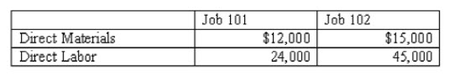
If overhead is applied to jobs at $.80 per direct labor dollar, the total manufacturing cost for the two jobs would be:
A) $ 96,000.
B) $151,200.
C) $ 55,200.
D) $162,000.
6. Assume that a statement of cash flows has been prepared. The sum of the three major components (operating activities, investing activities, financing activities) adds up to the:
A) change in the cash account balance between the beginning and end of the period.
B) net income for the period.
C) ending cash balance.
D) amount of cash inflow for the period.

7. A hybrid cost system contains:
A) features of a job-order cost system.
B) features of a process cost system.
C) features of both job-order and process cost systems.
D) none of the above
8. The Ragan Corporation uses a process cost system. The company started March with 2,300 units in Work in Process-Dept. A. During the month 4,000 units were started. At the end of the month there were 3,200 units in ending Work in Process-Dept. A inventory that were 30% complete. The beginning work in process balance was $240,540 and total manufacturing cost for the period was $608,000. Based on this information, the amount of cost transferred from Work in Process-Dept. A to Work in Process-Dept. B was:
A) $200,640.
B) $254,562.
C) $543,233.
D) $647,900.
9. Alton Company experienced an event that affected its financial statements as indicated below:
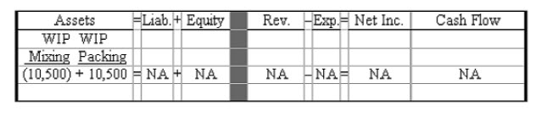
What type of product costing system is being used by this company?
A) Job-order cost system
B) Process cost system
C) Hybrid cost system
D) None of the above
10. During the 2007 accounting period the XYZ Company earned $55,000 of sales revenue on account and accrued $32,500 of operating expenses. The company also earned $6,400 of service revenue that had previously been recorded as unearned revenue. In addition, a $2,200 stock dividend was issued to the stockholders. What can be said about cash flows considering these transactions?
A) Cash outflows from financing activities are $2,200
B) Cash inflows from operating activities are $28,900.
C) Cash inflows from operating activities are $22,500.
D) There are no cash effects from these transactions.
11. In preparing the statement of cash flows by the indirect method, which of the following is an incorrect statement of one of the general rules to convert net income to a cash-basis equivalent?
A) Increases in current assets are subtracted from net income.
B) Non-cash revenue and gains are added to net income.
C) Decreases in current assets are added to net income.
D) Increases in current liabilities are added to net income.
12. Evelyn Company began the accounting period with $13,500 in accounts receivable. The ending balance in accounts receivable was $5,000. If the credit sales during the period were $22,000, what is the amount of cash received from customers?
A) $13,500
B) $22,000
C) $30,500
D) $40,500

13. Hatcher Company uses a process cost system. The following data applies to January 2007.
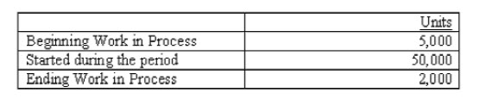
The ending work in process inventory is 90% complete. The total number of equivalent units for January was:
A) 51,200
B) 53,000
C) 54,800
D) 55,000
14. In a job-order cost system, the subsidiary accounts for the Work in Process account are the:
A) job cost sheets.
B) standard cost cards.
C) individual accounts payable accounts.
D) cost of production report.
15. On January 1, 2008, the ABC Company purchased equipment for $26,000 cash. On December 31, 2008, depreciation of $8,000 was recorded. Which of the following correctly shows the combined effect of these two events on the income statement and statement of cash flows?
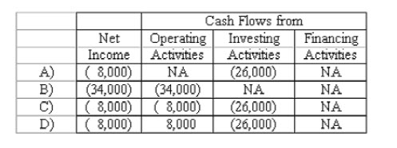
ABC uses the direct method to prepare the statement of cash flows.
A) A Above.
B) B Above.
C) C Above.
D) D Above.
16. Port Corporation reported a $1,800 balance in accounts receivable on January 1, 2006. During the year, $12,400 of sales on account were made. During the year, Port wrote off as uncollectible, accounts receivable of $850. If the ending balance of accounts receivable is $1,000, what is the amount of cash received from customers?
A) $10,600
B) $10,750
C) $12,350
D) $14,200

17. Select the correct formula for computing the cost to be assigned to ending inventory in a process costing system.
A) Ending inventory units x cost per equivalent units
B) Ending inventory equivalent units x cost per equivalent units
C) Beginning inventory cost + Transferred-in costs
D) Beginning inventory units + units transferred in - units transferred out
18. The entry to dispose of underapplied manufacturing overhead will include a:
A) debit to Cost of Goods Sold and a credit to Manufacturing Overhead.
B) debit to Cost of Goods Sold and a credit to Finished Goods.
C) debit to Manufacturing Overhead and a credit to Cost of Goods Sold.
D) debit to Finished Goods and a credit to Manufacturing Overhead.
19. The following income statement was drawn from the annual report of Hurricane Company:
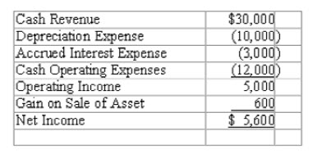
The amount of cash flow from operating activities is:
A) $18,600
B) $18,000
C) $13,000
D) $12,400
20. The Lemmon Corporation reported a beginning balance of $600 in its Prepaid Insurance Account for 2008. During the year, a total of $8,000 was recognized as Insurance Expense and the Prepaid Insurance account had an ending balance of $800. How much cash did Lemmon pay for insurance during 2008?
A) $8,600
B) $8,200
C) $8,000
D) $7,400
21. What effect will recording depreciation expense have on net income and cash flows?
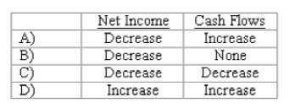
A) A Above
B) B Above
C) C Above
D) D Above
22. Which of the following is not a component of process cost systems?
A) Job cost sheet
B) Cost of production report
C) Multiple Work in Process accounts
D) All of the above are components of process cost systems.
23. Which of the following cash flows would be included under the operating activities section of the cash flow statement? Assume the direct method.
A) Cash receipts from dividends.
B) Cash paid to purchase equipment.
C) Cash received from issuing bonds payable.
D) Gains and losses from the sale of operational assets.
24. Which of the following transactions is a use of cash?
A) Short-term borrowing of cash
B) Acquisition of land by issuing a short-term note payable.
C) Issuance of a stock dividend.
D) Purchase of treasury stock
25. Which of the following would NOT be represented in the financing activities section of the statement of cash flows?
A) Purchased a new office building.
B) Purchased treasury stock.
C) Made installment payment on long-term note payable.
D) Issued preferred stock.

